If Ties Could Talk, part 6
From L to R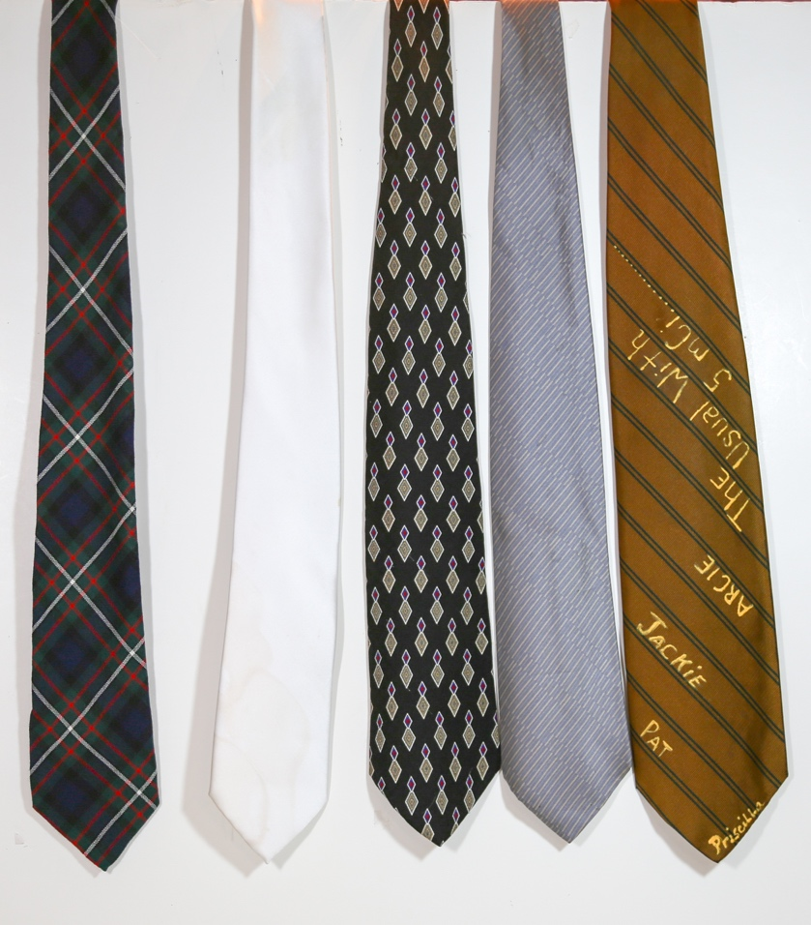
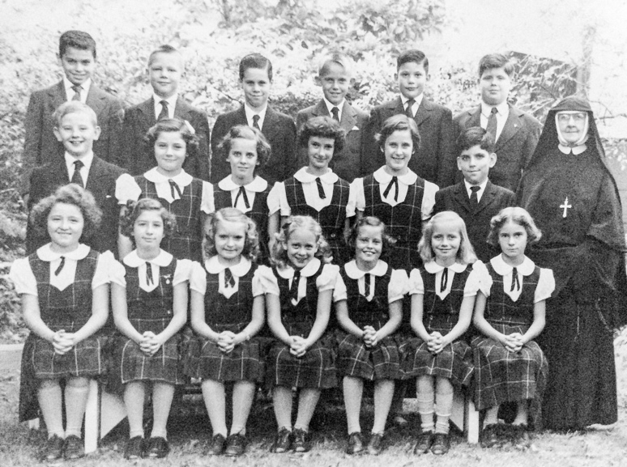
- Plaid with green background. This is a close approximation of the plaid fabric of the Saint Leonard’s Academy Uniform. It is actually the Ferguson clan tartan pictured here. Many years ago we had a reunion of the St. Leonard’s class of ’58. That is the grade (grammar, elementary) school class I attended for eight years. So I wanted to wear something appropriate to the occasion and saw this tartan and wore it proudly. (There was also a scarf of the same weave which Aleda wore.) It turned out that this was not the true pattern of the plaid of the girls uniform of the school on Chestnut Street in West Philadelphia. This tie was not worn as a school tie by the boys, but rather was a plain, dark blue tie with a dark blue sports jacket and typically blue trousers . The girls wore a uniform with a below the knee pinafore dress and a white short-sleeved blouse with a Peter Pan collar and a small necktie. There were also white or tan knee socks and typically brown shoes.
You will note that in this fourth grade class there were eleven girls and 8 boys. This was the last year of a “co-ed” class. The next four grades the boys and girls were separated and went to different classrooms in different buildings.
- A white tie. Towards the end of my tie wearing days the wardrobe colors tended to the color of black. Black jacket, black slacks and even a black shirt. I could wear my black tie, see elsewhere, but that was too monochromatic. So, for a more formal occasion, such as a wedding, I bought this white tie. However, it was only infrequently worn for the following: it made me look like a gangster and I didn’t have a fedora to complete the outfit and two, it was subject to the previously described problem of soup stains.
- A patterned tie with a diamond emblem and a small purple acccent mark. This has no particular significance or relevance other than it was not a plaid.
- A silver patterned tie.
- I call this the Stenos tie. (that is, the pleural of Stenographer. However, these gals were more likely formally called transcrisptionists. This was in the days before voice recognition and transcription. There was some feeling of affection between the dictator and the typist. (They sometimes said I was a great dictator because I wore a potato in my pants.) ssddddddddddddddddddddddd

