Harold F. Littlefield,
The Littlefield Who Won the War (literally, but not single-handedly)

It is generally recognized by historians that the Battle of Midway was the turning point in the war in the Pacific during World War II. Without this key victory the war would have lasted much longer and with many more casualties than those which occurred. And it is also recognized that the keys to the victory at Midway were primarily due to superior naval intelligence, excellent tactical decision making (with some exceptions) and the bravery and dedication of the men of the air and surface fleets of the US Navy. It is generally recognized that it was the sacrifice of the torpedo squadrons from the American carriers that allowed the dive bomber squadrons to annihilate three Japanese carriers on June 4, 1942. An additional carrier was sunk the next day. One of these squadrons was Torpedo Squadron Six (VT-6), commonly called “Torpedo Six” that flew from the USS Enterprise. Another and perhaps more familiar was Torpedo Eight (VT-8) from the USS Hornet, of whom the only survivor of those who flew off that day was Ensign George Gay. One of the men of Torpedo Six was Harold F. Littlefield. This is a brief account of his life and death.

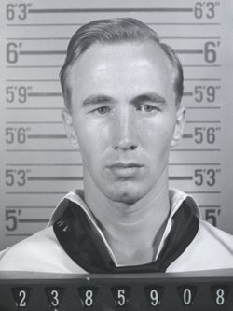
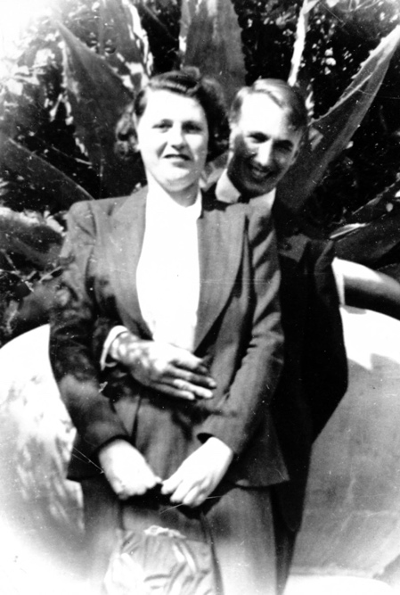
Harold Francis Littlefield was the fifth child and second son of Myron Jay Littlefield and Bertha May Mason (later Harbour) who were married in Bennington, VT on 27 Sept 1913. They were the parents of three other children: (1) Hazel Bertha (b. 1916 in NY, d. Battleboro of Pulmonary Edema and manic depression). She never married. (2) Lucinda May (b. Bennington, VT 15 Oct. 1916, d. 24 June 1975 Bennington, VT, multiple myeloma; m. Louis Francis Warner, 18 Nov. 1944), ch: daughter Joan Marie Paul of Denver, CO b. 12 Mar, 1944; d. 10 Jan 2009; occupation listed: cook, housekeeper (3) Lawrence Robert Littlefield (b. 28 Nov. 1919, Bennington, VT, d. 7 Oct. 1995 Bennington, VT, m. Dorothy Martha Blake. LRL was a dry cleaner; one child: Lawrence Edward Littlefield, b 1/28/1947 Bennington, VT,. (4) Harold Francis was born Sept 16, 1920 in Petersburg, NY.
After her husband died unexpectedly in 1929 leaving her with four young children to raise, Bertha struggled for three years before she married Harry Edward Harbour in 1932. This family like millions of others endured the extreme hard times of the Great Depression. Many of the children had to work to contribute to the family’s budget. Harold was no different. In the 1930 census, enumerated April 3rd, Harold was living with his brother Lawrence on Bank Street in North Bennington, VT. The head of the house noted as Fred C. Mattison with wife Minnie Q. and another non-related young child, Edward Welch, age 6. The boys are listed as “boarders”, though perhaps they were unofficial foster-children . At this time, Harold’s mother was working (and living) as a maid/cook in a house on Division Street of North Bennington for one Edward Riley and his wife Mary. Also the time of the census (again April 1930), the two older girls Hazel Bertha and Lucinda May were living in the Warner Memorial Home, which was in Saxtons River, about 60 miles from Bennington. This home was run under the direction of another institution for children, that is, Kurin Hattin (see next). Harold’s early education was received in North Bennington, where he lived to the age of 10. He attended the Kurin Hattin home for children afterward. By 1935 (age 15) he was living in Framingham, MA. In the 1940 census is listed as living in San Diego, 6th Street, Apt 7B, along with his wife, Gertrude. His occupation is listed as “radio” and “navy”. She is listed as “waitress” in “sandwich shop”, although this was crossed out.
Harold held a “good” job according to a letter his mother wrote to the Navy on 24 Jan 1938 shortly after Harold arrived at basic training in Newport, RI. She lamented the fact that Harold quit a good job to join the navy and he had to wait around the house for a month for his appointment in the Navy with no income forthcoming. It seems that Harold had owed her $20.00 for board and had not paid her anything. She stated that her husband was laid off from his job, and they very much needed the money to feed and clothe their three other children. Could the Navy get Harold to pay her what was owed? As seen through the eyes of a woman grappling with the hardships of the Great Depression, one can see how difficult circumstances must have been if she had to press her son to pay his board fee of $20.00. It is also worth noting that three years later, his pay sufficiently increased, Harold signed up for a National Service Life Insurance policy worth $9,000.00 effective 01 Mar 1941. His wife was principal beneficiary and his mother was the contingent beneficiary.
Harold F. Littlefield, who had completed the eighth grade level of education, submitted an application for enlistment into the US Navy on 20 Oct 1937 in Schenectady, NY. After his mother, Bertha May Harbour, signed the consent form on 20 Nov 1937, Littlefield signed a "minority" enlistment for four years as an Apprentice Seaman (A.S.) in the US Navy (238-59-08) on 4 Jan 1938 at the Naval Recruiting Station, Albany, NY. He was transferred to the Naval Training Station (NTS), Newport, RI for basic training. After completing basic training on 01 April 1939, Littlefield took 12 days of recruit leave. Littlefield was detached from the NTS on 3 May 1938, and he transferred on 04 May to the Receiving Station, Norfolk, VA for further transfer to the aircraft carrier USS Enterprise's (CV-6) pre-commissioning unit. As noted below, the Enterprise was commissioned 12 May 1938. As such, he could claim to be called a “plankowner”.
Harold Francis was married before the war to Gertrude Beacher Forehand. Gertrude was born 2 Nov 1921 in Edenton, N.C. She met her first husband, Harold F. Littlefield, at Ocean View Amusement Park (Norfolk, VA) and they were married 15 April 1939 in South Mills, Camden, NC. (note: South Mills is in North Carolina, just across the border from Virginia, and about 40 miles south of Norfolk.) He was 19 and she was 17. He was in the U.S. Navy assigned to Torpedo Squadron Six stationed aboard the USS Enterprise (CV-6) in Norfolk. He was a radioman and rear seat gunner of an airplane called the Douglas Devastator Torpedo bomber (TBD). They had one son, Harold Francis Littlefield, Jr. As will be seen, Harold Francis was engaged in operations against the enemy during the Battle of Midway June 4, 1942. He was reported "missing in action" from that battle and was never recovered. As a result, their son, Harold F. Littlefield Jr., (born 18 Jan 1942) never got to see his father.

Gertrude's second husband was William Herman Zwicker also served in the U.S. Navy during World War II. They were married 17 Sept 1943 in South Mills, Camden, NC. (Ed.: am I getting a pattern here?) He was a ship's cook and was stationed aboard LSM 384 with the amphibious force in the Pacific Theater. They were married Sept. 17, 1943. She passed away July 7, 2009 at age 87 in Portsmouth, VA and is buried in Norfolk. Gertrude leaves two sons, Harold F. Littlefield with his wife Debbie of Portsmouth, VA and Jack H. Zwicker with wife Miranda (141 Forest Dr., Wellsburg, WV 26070).

The USS Enterprise (CV-6) “The Big E”
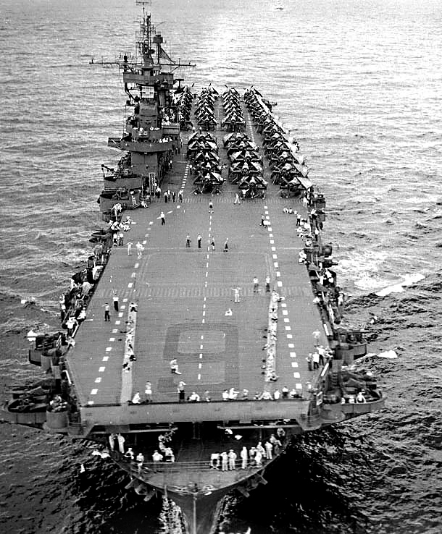
She was the sixth aircraft carrier in the US Navy. She participated in more major actions of the war against Japan than any other United States ship. Enterprise earned 20 battle stars, the most for any U.S. warship in World War II, and was the most decorated U.S. ship of World War II. She is also the first American ship to sink an enemy warship during the Pacific War when she sank Japanese submarine I-70 on 10 December 1941. After commissioning she operated along the East Coast and the Caribbean until April 1939 when she was ordered to duty in the Pacific. (Remember, Harold and Gertrude were married 15, April, 1939 in North Carolina). After transit, she was first based out of San Diego and then Hawaii.

Enterprise was launched 3 October 1936 at Newport News Shipbuilding and was commissioned on 12 May 1938, and Littlefield reported on board for duty. He was transferred to Torpedo Squadron Six (VT-6) that was attached to the Enterprise on 20 Sep 1938 for duty. He was advanced in rate from A.S. (Able Seaman) to Seaman Second Class (S2c) the same day. During 1939, Enterprise and her embarked squadrons conducted shake down cruises and workup exercises at various times. After transit of the Panama Canal, the Enterprise joined the Pacific Fleet April 1939 in San Diego. While the ship was in port, the squadrons were temporarily based ashore at their assigned airfields. Their tempo of operations increased during 1940. He was advanced in rate to Seaman First Class (S1c) on 16 Feb 1940. On 16 Jun 1940, Littlefield received orders to duty involving regular and frequent aerial flights in aircraft as an aircraft radioman. On 01 Oct 1940, Littlefield completed instruction in belting and loading ammunition, cleaning, servicing, and upkeep of the Browning automatic machine gun. He was advanced in rate to Radioman Third Class (RM3) on 16 Nov 1940.

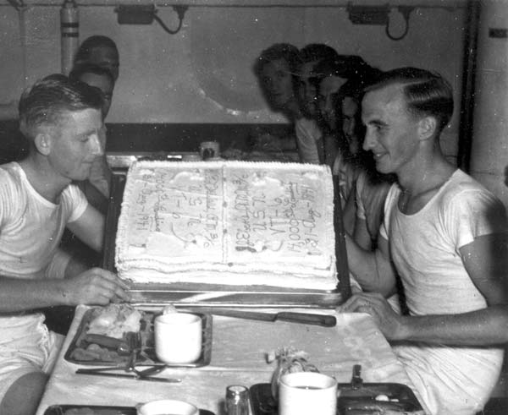
There is one interesting photo from that time period, a picture of Harold which appeared in Life magazine, issue uncertain. Caption also is somewhat curious: Harold G.(ed. ?) Littlefield (left) and John J. Eberle of Torpedo Six celebrate the 14,000th landing on Enterprise CV-6, 21 August 1941 (as dated on the cake). Littlefield was later killed in action at the Battle of Midway, 4-6 June 1942. (from Enterprise Image Library: www.cv6.org/noumea/default.htm)

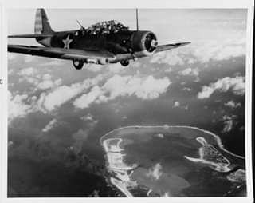
During the months prior to 7 Dec 1941, and the entry by the United States into WWII, Enterprise shuttled Army Air Force P-39s and P-40s, as well as Navy aircraft from US West Coast ports to Pearl Harbor and beyond. On 28 Nov 1941, Enterprise left San Diego with a cargo of Marine Fighting Squadron 211 (VMF-211) aircraft and pilots destined for Wake Island. The Marine pilots and their planes flew from Enterprise to Wake Island on 02 Dec 1941. Enterprise was scheduled to arrive back in Pearl Harbor on 06 Dec, but was delayed due to inclement weather. Fortunately, she wasn't in port on the morning of 07 Dec but arrived later that evening.
Harold Littlefield was honorably discharged from the Navy on 08 Dec 1941. He reenlisted as an RM3 on 09 Dec 1941 at Pearl Harbor, HI for a period of four years. The next day, he qualified for duty as an Aircraft Radioman. Several weeks later on 01 Jan 1942, RM3 Littlefield was advanced in rate to Radioman Second Class (RM2). A little know fact (as noted by one of his fellow shipmates) was that he was nicknamed “Feets”, apparently in reference to his shoe size.
In the first five months of 1942, Enterprise and her Air Group participated in the Gilbert and Marshall Islands raids and Wake Island Raid in Feb 1942. This picture depicts a moment from the Battle of Wake Island, February 24, 1942. This is one of nine TBD-1 Devastators from VT-6 that went into the fray armed with 100-lb general purpose bombs. This plane is 6-T-5 (Bu. No. 0368) flown by ENS J. P. Gray (pilot) and his crew, RM 2/c H. F. Littlefield and AOM 2/c O. G. Fowe. You can see Wake Island clearly, about 12,000 feet below the plane. Four months later, this plane flew at the Battle of Midway, June 4. It was one of only four TBD-1 Devastators to return to the fleet. The occupants in this photograph were not so lucky. ENS Gray did not survive the battle. He was killed in action while serving with another squadron, Torpedo Squadron Eight, which lost all fifteen of its TBD-1s. The gunner, Littlefield, was also killed in action while serving with Torpedo Six, shot down in 6-T-7, killing him and his pilot, LTJG Lloyd Thomas. (from Never Call Me a Hero or Facebook).

On 01 Feb 1942, VT-6 attacked Japanese forces on Kwajalein and Wotje. Petty Officer Littlefield participated in that attack (on Wotje) as a member of a flight crew in the bombing planes, (plane 6 VT 5) with Ens. J.P. Gray as pilot and AOM2c O.G. Fowe as bombardier and Littlefield as gunner. He changed his rate on 01 March 1942 from RM2 to Aviation Radioman Second Class (ARM2). In March, Enterprise’s Air Group attacked enemy installations on the Marcus Islands raids, and in April, she supported the Doolittle raid. In early May, Enterprise and the aircraft carrier USS Hornet (CV-8) were sent to the South Pacific to assist the aircraft carriers USS Lexington (CV--2) and USS Yorktown (CV-5) who were engaged in the battle of the Coral Sea. However, before the ships arrived on-scene, the battle of the Coral Sea was over. After participating in additional operations in the Central Pacific, Enterprise returned to Pearl Harbor on 26 May and began intensive preparations to meet an expected Japanese thrust at Midway Island. On 28 May, Enterprise and Hornet sortied from Pearl Harbor and proceeded toward Midway, to a place designated as “Point Luck”, north east of Midway Island.

The Battle of Midway June 4, 1942
0906 Enterprise launches attack groups including 14 VT’s aircraft which including plane 6T7 TBD1 (Bureau no. 0294) piloted by Lt. (jg) Lloyd Thomas and Harold F. Littlefield, as radioman/gunner (plane navy i.d. 238 59 08), ARM2c, USN.

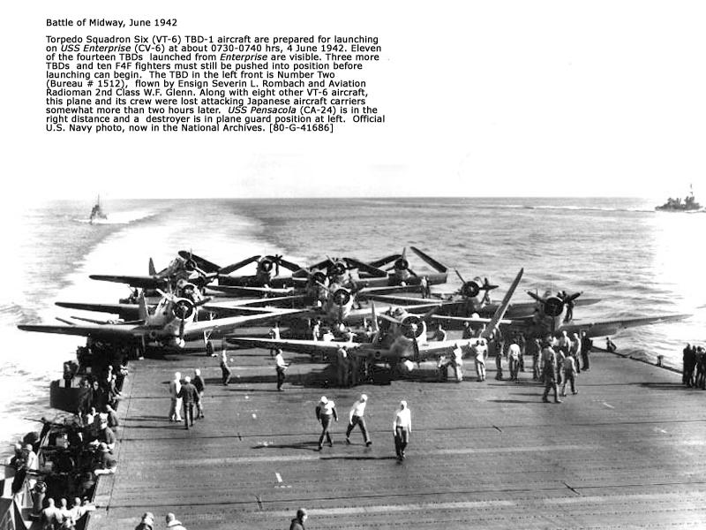
On the morning of 4 Jun 1942, pilot Lt jg Lloyd Thomas (Thomas had joined VT6 13 Dec 1939) and his radioman-gunner Aviation Radioman Second Class Harold Francis Littlefield launched their torpedo plane, a Douglas Devastator torpedo bomber TBD 6-T-7, Bu No 0294 from USS Enterprise (CV-6) along with other members of VT-6 and Air Group Six (an air group consists of torpedo bombers, level/dive bombers and scouting/attack fighter planes) to attack the Japanese striking force (called Kedo Butai, meaning “Mobile Force”) that was approaching Midway.

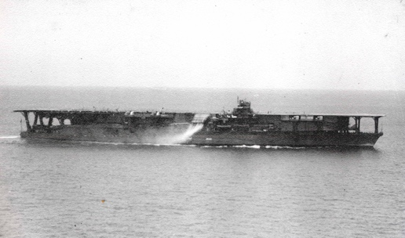
The “Big E’s” TBD crews spotted smoke to the northwest. Seeing three carriers inside a six and fifteen-mile outer screen, Lt. Cdr Lindsey sent his second division under Lt. Art Ely to starbord. The CO (Lindsey) hoped to trap the 38000 ton Kaga (right) in a hammer and anvil attack, but the big carrier swung away from her westerly heading to the north, prolonging the approach for both VT-6 divisions. 1220 VT groups commenced attack. About ten minutes after the initial sighting, the Devastators were discovered and a cruiser opened fire with her “8-inchers” to show the Zeros where to look. Japanese fighter direction, although unsophisticated, proved effective. Like VT-8 before it, Torpedo Six tackled an aroused defense now numbering 34 fighters, in addition to two battleships, three cruisers and a dozen destroyers.

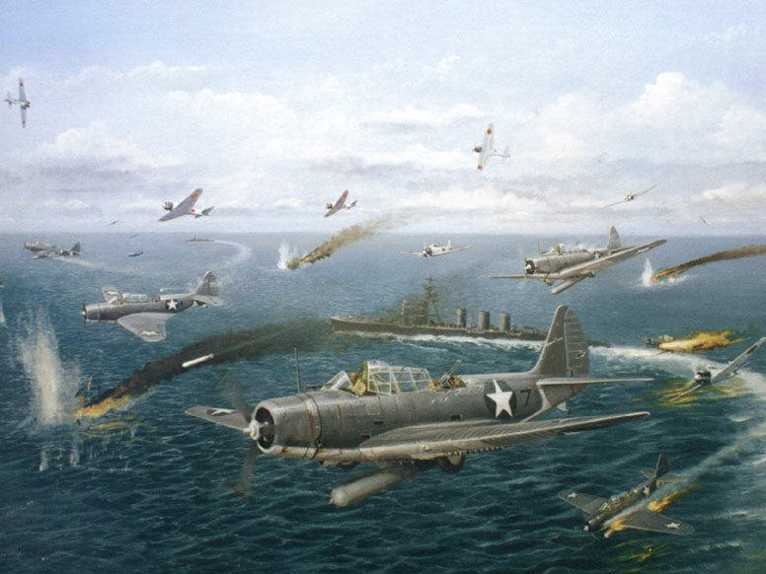
Separated from their covering fighter protection, VT-6 comprised of 14 torpedo planes pressed their attack even though overwhelmed by superior numbers of Japanese fighter aircraft and heavy anti-aircraft fire. One by one, the planes of VT-6 were shot down. Of the 14 torpedo planes that attacked the Japanese carriers from Enterprise, only four returned. LT jg Thomas and Petty Officer Littlefield did not return from their mission. According to the USS Enterprise after action report for the Battle of Midway dated 8 Jun 1942 for VT-6, Ltjg L. Thomas, USN and ARM2 H.F. Littlefield, USN were listed among the personnel losses. Their remains were unrecoverable. The Navy Dept. sent a telegram to Littlefield's wife, Gertrude, dated 17 Jun 1942, to inform her that her husband was missing in action. Littlefield and his pilot were declared "presumed dead" on 5 Jun 1943. The painting shows the seven TBDs of Ely’s Division, with the one in the foreground being the Thomas/Littlefield TBD from 6-T-7.
Source: After action report of G.D. Murray: Battle of Midway: 4-7 June 1942, Online Action Reports: Commanding Officer, USS Enterprise, Serial 0133 of 8 June 1942 : The attack delivered upon enemy carriers by the torpedo squadrons of our forces is believed to be without parallel for determined and courageous action in the face of overwhelming odds. These crews were observed to commence their attack against heavy anti-aircraft fire from the enemy carriers and supporting vessels while opposed by enemy Zero fighters in large numbers. The enemy fighter opposition was so strong and effective that ten torpedo planes out of fourteen of Torpedo Squadron SIX did not return. It is recommended that the Navy Cross be awarded to each pilot and gunner of Torpedo Squadron SIX who participated in this bold and heroic attack.

Lt. Ely, the executive officer of VT-6 group of planes, radioed for the VF-6 fighter escort to “come on down”, but apparently the Wildcats never heard the call. Already concerned about fuel, they orbited overhead for nearly 30 minutes before turning for home. Consequently, TorpRon Six went in alone. The numbers just didn’t work. Forced into a stern chase, the TBD’s only had an 85 knot advantage on the 26-knot Kata, their Mk 13’s less than that. Lindsey’s crews were exposed to AA for around 15 minutes ---. Then the fighters piled in. Although VT-6 also had twin-mount .30 cals., they ceded their tormentors a 200-knot advantage. By ones and two the TBDs were downed…. No pilot gained more than a 70-degree angle on either bow, none got closer than 800 yards. Perhaps six torpedoes went into the water, aimed at Kaga, but none connected in their 12-ft deep runs. Five airplanes cleared the Japanese task force.
From: TBD Devastator Units of the Units of the US Navy, by Barrett Tillman,

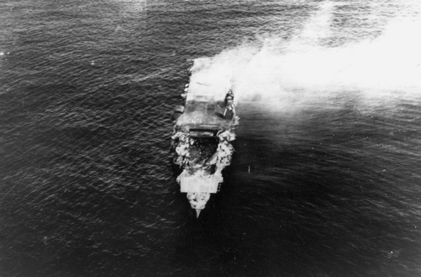
Soon after the torpedo plane attacks, American carrier dive bombers arrived over the Japanese carriers almost undetected and began their dives. At 10:22, 25 SBD Dauntless dive-bombers from Enterprise, led by C. Wade McClusky, hit Kaga with one 1,000-pound (450 kg) bomb and others with at least three 500-pound (230 kg) bombs. The first landed near her rear elevator and set the berthing compartments on fire, and the next bomb hit the forward elevator and penetrated the upper hangar, setting off explosions and fires among the armed and fueled planes on her hangar deck. Captain Okada and most of the ship's senior officers were killed by the third bomb, which hit the bridge. The 1000-pound bomb hit amidship and penetrated the flight deck to explode on the upper hangar. The explosions ruptured the ship's avgas lines, damaged both her port and starboard fire mains and the emergency generator powering her fire pumps, as well as knocking out the carbon dioxide fire suppression system. Fueled by the avgas pouring onto the hangar deck, the fires detonated the 80,000 pounds (36,000 kg) of bombs and torpedoes strewn across the hangar deck in a series of catastrophic multiple fuel-air explosions that blew out the hangar sides.

The following was noted in the Bureau of Personnel magazine, “All Hands” from April 1943, #313, p 50 – 51: “The following, all missing in action, who served as free gunners and radio operators of planes in a torpedo , squadron in the Battle of Midway, for returning the fire of enemy Japanese fighters so as to enable their pilots to press home attacks against concentrated antiaircraft fire and violent fighter opposition”: Harold Francis Littlefield, ARM2c USN of Bennington, VT. This was taken from the DFC awarded. The others, radiomen-free gunners are also listed in this brief article and are noted below.

Memorial
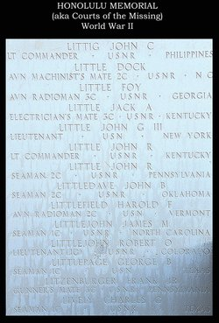
Harold F. Littlefield is enscribed on the Honolulu Memorial Courts of the Missing, World War II. This is in the Punchbowl Cemetery just outside of Honolulu, Hawaii.

In a letter sent by the Acting Commanding Officer of VT-6 to the Commander in Chief, US Pacific Fleet (CINCPACFLT), dated 10 Jun 1942, Petty Officer Littlefield was recommended for the award of the Navy Cross. After review, CINCPACFLT recommended that Littlefield be posthumously awarded the Distinguished Flying Cross (DFC). He was also posthumously awarded the Purple Heart medal, Presidential Unit citation, American Defense Service Medal with "Fleet" clasp, Asiatic-Pacific Campaign Medal with two battle stars and the World War II Victory Medal. His family was also presented with a Presidential commemoration.
----------------------------------------------

AWARDS AND MEDALS
The President of the United States of America takes pleasure in presenting the DISTINGUISHED FLYING CROSS to HAROLD F. LITTLEFIELD, AVIATION RADIOMAN SECOND CLASS UNITED STATES NAVY for service as set forth in the following CITATION:
"For extraordinary achievement and heroic conduct in aerial flight as a free gunner and radio operator of an airplane in Torpedo Squadron SIX in action against enemy Japanese forces in the Battle of Midway, June 4-6, 1942. LITTLEFIELD's unflinching devotion to duty and his courageous determination in returning the fire of enemy Japanese fighters enabled his pilot to press home an attack against concentrated anti-aircraft fire and violent fighter opposition. His marked integrity in maintaining continuous fire in the face of such tremendous odds and his complete disregard for his own personal safety were in keeping with the highest traditions of the United States Naval Service."
[Citation wording is from a copy in his service record]
General Orders: Bureau of Naval Personnel Information Bulletin No. 313 (April 1943)
---------------------------------------------------------------
USS Enterprise Presidential Unit citation (1942)
For consistently outstanding performance and distinguished achievement during repeated action against enemy Japanese forces in the Pacific, war area, 7 December 1941, to 15 November 1942. Participating in nearly every major carrier engagement in the first year of the war, the Enterprise and her air group, exclusive of far-flung destruction of hostile shore installations throughout the battle area, did sink or damage on her own a total of 35 Japanese vessels and shot down a total of 185 Japanese aircraft. Her aggressive spirit and superb combat efficiency are fitting tribute to the officers and men who so gallantly established her as an ahead bulwark in the defense of the American nation.
-----------------------------------------------------------
His family also received an honor scroll from President Franklin D. Roosevelt in commemoration of Petty Officer Littlefield. The commemoration reads: In grateful memory of Harold Francis Littlefield who died in the service of his country, SEA, Pacific Area, ATTACHED U.S.S.ENTERPRISE, 5 JUNE 1943 (Presumed)*. He stands in the unbroken line of patriots who have dared to die that freedom might live, grow, and increase its blessings. Freedom lives, and through it, he lives -- in a way that humbles the undertakings of most men.
(Signed) Franklin D. Roosevelt,
President of the United States
(*Presumed dead on 5 Jun 1943. Actual date gone missing was 4 Jun 1942.)
--------------------------------------
Of the 14 Torpedo Bombers from VT-6 that flew against the Japanese on 4 Jan 1942 only four returned to Enterprise. Machinist Albert Walter Winchell (NAP), and his gunner, Aviation Radioman 3rd Class Douglas M. Cossitt, made a water landing before sighting Enterprise. They survived 17 days on the open seas in a rubber raft before being rescued by a Patrol Squadron 24 PBY on 21 Jun 1942, some 360 miles northward of Midway. In all, five VT-6 crews survived the morning attack.
--------------------------------
These are the pilots and crew of VT-6 that were killed in action on 04 June 1942:
1) Lt Arthur Vincent Ely (VT-6 XO) and his gunner, RM3 Arthur Richard Lindgren
2) Lt Paul James Riley and his gunner, ARM2 Edwin John Mushinski
3) Ltjg John Thomas Eversole and his gunner, RM2 John Udell Lane
4) Ltjg Randolph Mitchell Holder and his gunner, ARM3 Gregory Joseph Durawa
5) Ltjg Severin Louis Rombach and his gunner, ARM2 Wilburn Forrest Glenn
6) Ltjg Lloyd Thomas and his gunner, ARM2 Harold Francis Littlefield
7) Ensign John Wiley Brock and his gunner, ARM3 John Melville Blundell
8) Ensign Flourenoy Glenn Hodges and his gunner, RM2 John Hail Bates
9) Lcdr Eugene Elbert Lindsey (CO VT-6) and his gunner, ARMC Charles Tilden Grenat
----------------------------------------
Contrary to what some researchers have stated, neither Lt jg Holder nor any of the Navy/Marine Corps aviators who engaged in aerial combat during the Air Battle of Midway were/are eligible for the Combat Action Ribbon (CAR). See SecNavInst 1650.1H (Navy/Marine Corps Awards Manual dated 22 Aug 2006) for award criteria details.

Harold Francis Littlefield: DFC

The President of the United States of America takes pride in presenting the Distinguished Flying Cross (Posthumously) to Aviation Radioman Second Class Harold Francis Littlefield (NSN: 2385908), United States Navy, for heroism and extraordinary achievement while participating in aerial flight. A free gunner and radio operator of a Torpedo Squadron SIX (VT-6) airplane in the Battle of Midway, 4 to 6 June 1942, he manned his gun and continued to return fire of Japanese fighters with such courage and utter disregard for personal safety that he enabled the pilot to press home his attack in the face of continued fighter opposition. It is difficult to conceive of a situation where a free gunner would be forced to fight against such desperate odds as were encountered in this attack. The courage and devotion to duty he displayed were in keeping with the highest traditions of the United States Naval Service.

Much of this material is taken from: Harold Francis Littlefield in: (Find A Grave: https://www.findagrave.com/memorial/185298906/harold-francis-littlefield )
The Bureau of Medicine and Surgery, Navy Department, Certificate of Death of Aug. 7th, 1943, noted the following physical description of HFL: Height: 71 ½” Weight 162 ½ lob, Blue eyes, light brown hair, Ruddy complexion. Marks, scars: “V” scar 5” RT ant leg, mole lt breast, V scar lt arm, Burn scar, 5” x 3” lt thigh anter., Burn mark, left knee, scar ½” left lower leg. Posterior: lt. arm, scar 1” lt hand, scar 2” Left leg, scar 1” rt hand, scar ½” rt buttock.
I. Myron Jay Littlefield was born in Petersburg, (near Vermont) Rensselaer County, NY in 1887. He was the son of Marsden O. Littlefield, also born in New York, and Mary Q. Littlefield, also born in New York. Myron had five siblings: Chauncy M. (b. 1885), Ma??? (b. 1887), Hattie (b. 1892) and Laurence (b. 1896). This last, Laurence, was born in Bennington, VT 11/28/1896, and died 10/7/1995 at age 76 and is buried in Bennington. He was a Nurses Assistant. At age 13 (1900 Census) he was living in Petersburg. He worked as a machinist in a paper mill. II. Myron was descended from the line of Littlefields in Maine, the progenitor being known as “Old Edmund L.” of Maine. From Myron thru preceding generations: (Myron J.12, MARSDEN O.11, JOSIAH J.10, JOSHUA H.9, JOSHUA8, DANIEL7, DANIEL6, EDMUND5, EDMUND4, ANTHONY3, EDMUND2, FRANCIS1). III. Edmund Littlefield, the father of Wells, Maine, established a permanent home, sawmill and gristmill as early as 1640-41 at the falls of the Webhannet River. (Comment: the author, James L. Littlefield, is not directly related to any of the above. His ancestors, as does this family, go back to Titchfield, England, but he is descended from another Littlefield called “William of Maryland” because the first immigrant was William Littlefield and he first settled in Maryland. However, DNA analysis of the two family lines reveals that there is a high likelihood that they had a common ancestor sometime before their emigration to the colonies. Christened on June 27, 1593 in Titchfield Co., Hants, Hampshire, England. Titchfield is in the southern part of England not far from Southampton. IV. This Edmund family arrived in America in 1637 during the Puritan Movement from England. Records show that Edmund first brought his sons, Francis & Anthony with him. They landed in Boston, MA. We find this family living in Wells, ME. Records of their Wills are published in ME. Wills Court records on July 16, 1662, p. 3 & 4. Will dated Dec. 11, 1661. In 1638 Agnes (his wife) & 6 children came to America on the ship, 'Bevis'. In 1639 they were assigned 21 acres of Upland & were a signer of Exeter Combinations (an agreement for self gov't. (June 5, 1639). In 1641 they left Exeter, N.H. with Rev. John Wheelright for Wells, ME. On July 14, 1643, in Wells, ME., they were granted 100 acres by Sir Thomas Gorges. In 1645 Edmund served on the grand jury. He was the Selectman of Wells in 1654 & 1657. He had grants on Webhanset in Wells & mills for lumber & grinding grain. He was the first settler & built the first house. He owned a saw & grist mill & was the richest man in Wells. He & his sons were millmen & farmers. He was one of a committee to settle the boundary between Wells & Cape Porpoise. Littlefield, was a prominent name from the original settlement of York Co., ME. up to the present time. Many of their names have figured prominently in public affairs, developing its agricultural & industrial interests. A sturdy, energetic people whose parent stock was inclined to favor free thought in the matter pertaining to religion. They were stern supporters of the theological doctrine advocated & practiced by the Rev. John Wheelright. In Maine, Edmund he was known as 'Old Edmund L'.
Bertha Mason Littlefield (later Harbour) was born in 1895 . By 1920 the family had moved to Factory Street in Bennington. Her father and mother were both born in New York. She and Myron Jay had four children: see above.
Possible current address of Lawrence Edward Littlefield: 12 Patoine Pl Old Orchard Beach, ME 4064 (from Family Tree Now)
Kurn Hattin Homes for Children is a non-profit located in Westminster, Vermont, serves as a charitable home and school for boys and girls, ages 6–15, who are affected by tragedy, social or economic hardship, or other disruption in family life. It was founded in 1894 by Reverend Charles Albert Dickinson,^{[1]} and was originally called New England Kurn Hattin Homes.^{[2]} It is the oldest childcare organization in the northeast United States to be continuously supported completely by charity.
It’s not stated what that good job was. Thus from the time he finished school in 8th grade (about 1932) until he joined the Navy in 1938, it’s not certain of his location or occupation
The TBD Devastator was the US Navy first monoplane torpedo-bomber, and it embodied many new features. Combat tactics changed little from the biplane era, however. An effective torpedo attack requires a slow and steady approach, and this made the Devastators easy targets. Once the TBD had braved fighters and ships' guns of all calibers, the success of its attack depended on whether the torpedo ran true and if it actually exploded against the target. US wartime torpedoes were notoriously ineffective. Although Devastators sank one Japanese 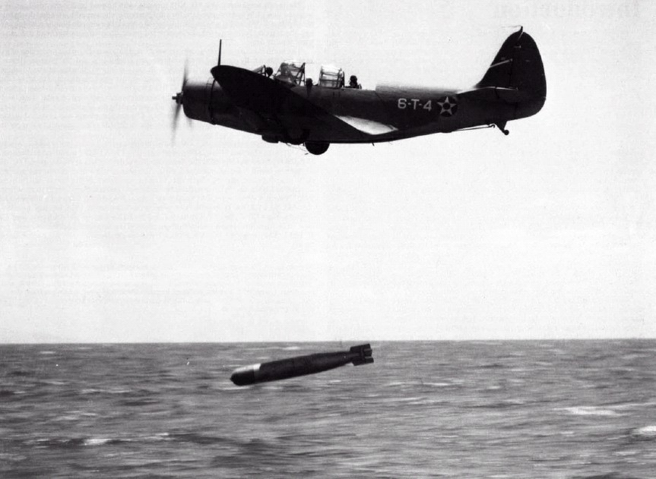carrier at Coral Sea, the Battle of Midway in June 1942 saw the TBD force wiped out without inflicting damage on the Japanese. Only five of the 41 TBDs involved in the battle made it back and the battle left fewer than 20 TBDs in the inventory. By August 1942 they were withdrawn from the front line. Apart from the fact that it was slow the Devastator's main drawback was its lack of defensive firepower. The single 0.30-inch machine gun mounted in its rear cockpit was completely inadequate against the heavy-caliber weapons of the Japanese Mitsubishi A6M Zero fighters, which accounted for the majority of the TBD losses in the Battle of Midway. Subsequent US Navy attack aircraft were much better armed, as Japanese fighter pilots often found to their cost. This American torpedo bomber is remembered mostly for a tragic reason - the Douglas TBD Devastators fell in flames at Midway, where an entire squadron was lost in a matter of minutes. The Devastator was perfectly acceptable aircraft by prewar standards, but it came on the scene when change was occurring rapidly. By the time men and machines were pitted in combat in the Pacific, the TBD was no longer an effective warplane. In the accompanying picture, note that From: http://www.fiddlersgreen.net/models/aircraft/Douglas-Devastator.html
Comment: since Harold Frances, Jr. was born January 1942, and since the Enterprise left Norfolk for the West Coast in 1939 and was based in San Diego from April 1939 and later, Hawaii, from about May or June of 1940 when the West Coast fleet was “forward based” to Hawaii by President Roosevelt this suggests Gertrude visited San Diego. However, the ship made visits to its home port in San Diego from 1939 to 1941. it might be assumed that Gertrude either visited HFL in San Diego or rented an apartment there. It is not known that she ever went to Hawaii. If one examines the photo above of Harold and Gertrude, they seem to be posed in front of an agave cactus, native to desert regions such as San Diego, this suggests that Gertrude did visit San Diego.
Obituary for Gertrude Beacher Zwicker, kindness of Michael Baker of “Carolina Cousins” from the Virginian-Pilot, Norfolk, VA, July 14, 2009. NORFOLK - Gertrude Beacher Zwicker, 87, passed away July 7, 2009, at Churchland House Assisted Living in Portsmouth where she resided for the past four years. She resided in Norfolk for most of her childhood and adult life. She lived many years on Jenifer Street in Snug Harbour. Born in Edenton, N.C., Nov. 2, 1921, she was daughter of the late Henry Beacher Forehand and Gertie (Harris) Forehand. Her mother passed away three days after giving birth, leaving baby Gertrude and her sister, Wessie (Forehand) Griffin (Louis E. Griffin) of Norfolk, and brother, the late Wesley J. Forehand, without a mother. Her father remarried in Edenton, but baby Gertrude was taken to Norfolk and raised by her father’s sister, the late Nonie A. Forehand and her late husband John Calvin Forehand. Their family included five late daughters, Mrs. Alma (Forehand) Rogister, Mrs. Edith (Forehand) Sanford, Mrs. Elizabeth (Forehand) Hill, Mrs. Gertrude (Beacher/Forehand) Zwicker, and Mrs. Hazel (Forehand) Jones, plus the late son, William E. Forehand and sons, Thomas E. Forehand and Fred L. Forehand. Upon the remarriage by Gertrude’s father, the late Henry B. Forehand, additional daughters included Mrs. Dorothy (Forehand) Schroeder and Mrs. Maybelle (Forehand) Hollowell, plus two sons, Thomas H. Forehand and Glenn W. Forehand. Gertrude met her first husband, Harold F. Littlefield, at Ocean View Amusement Park and was married in 1939. He was in the U.S. Navy assigned to Torpedo Squadron Six stationed aboard the USS Enterprise (CV-6). He was a radioman and rear seat gunner of an airplane engaged in operations against the enemy during the Battle of Midway June 4, 1942. He was reported "missing in action" from that battle and was never recovered. As a result, their son, Harold F. Littlefield Jr., never got to see his father. Gertrud’s second husband, the late William H. Zwicker, also served in the U.S. Navy during World War II. He was a ship’s cook and was stationed aboard L.S.M. 384 with the amphibious force in the Pacific Theater. They were married Sept. 17, 1943. Gertrude leaves two sons, Harold F. Littlefield with wife Debbie of Portsmouth and Jack H. Zwicker with wife Miranda of Wellsburg, W.Va.; plus several grandchildren, great- grandchildren, and great-great grandchildren. She was active in the woman’s social group the Degree of Pocahontas, Council Okee No. 44, Order of Red Men for several years in the 50s and 60s. Many train trips were enjoyed with her lady friends going to conventions about the state of Virginia for the organization. She enjoyed traveling, golf, bowling, fishing, dancing, and tennis, mostly in her younger days. She loved to be with her friends to see the Tidewater Tides play baseball. She was a competitive duckpin bowler into her later years. Gertrude was a Baptist by faith and attended Bayview Baptist Church and in her later years, Brendwood Baptist Church. She was always fun to be with, and spent many hours helping friends work at the local flea market. Her special friends, Kathy, John and Linda, Lee, and Helen will miss her. She worked several part-time jobs: food demonstrator, packing frozen foods, grading and packing eggs, waitress at a drug store, plus took care of children in her home for several working parents. She was also a housewife. A special "Thank You" is offered to Gertrude’s granddaughter, Cammie J. Phillips of Chesapeake, for the attention and love she provided her grandmother while living in the assisted living facility. A graveside service for the family was held July 10, 2009 at Woodlawn Memorial Gardens, Norfolk. Gertrude was buried next to her husband, William H. Zwicker, at the Avenue of Flags. The service was preformed by Pastor W. Joe Newman of Chesapeake. Her great- granddaughter, Sarah, played on the violin, "Amazing Grace." After the service, a luncheon was held for the family at the home of Cammie and her husband Chris Phillips. A special thanks to the Churchland Home staff for there care and kindness during Gertrude’s stay. Gertrud’s favorite saying was: "It’s a good life, if you don’t weaken." Gertrude was truly loved by her family and will be missed by many. May she rest in peace!
Response which I received on the Battle of Midway Roundtable (see next reference) regarding HFL: “I cannot say that Littlefield was not on the Lexington, at any time, BUT, I joined Torpedo Six in August of 1941 and I am fairly sure that he was in VT-6 at that time; - first, let me state that the Enterprise left San Diego in early May, of 1941, for what was to be a period of approximately eight (8) months of training, for wartime conditions, in the area of Hawaii. Littlefield had been given the nickname of "Feets" by someone, because he had big feet, and the name stuck; - we all called him "Feets" - anyway, by sometime around late October, or November, we had a couple or three periods where the "Scuttlebutt" was being passed around that we were going back to the states, in a week or so. Littlefield's wife was pregnant when we left San Diego and she gave birth to a boy some time while we were out in Hawaiian Territory; - I heard "Feets", at least one time, if not more, say something about sure wanting to get back there so he could see that boy!! It has always been one of the outstanding memories, with me, that we never got back there and "Feets" never got to see that boy!!! And, yes, I do remember Mr.Thomas, his pilot. I guess I have told many, many people about "Feets" not getting to see his Son!! --beyond this, I cannot give you any definitely known information on Littlefield.” Ron Graetz
The TBD Devastator was an aircraft that could be either a level bomber or a dive bomber or a torpedo bomber. For the first two mission, it could, and frequently did, carry a three man crew: pilot, radioman-bombadier and a rear gunner, as noted in the annotation.
For those who are interested in further study of the Battle of Midway, the two best sources are: The website: The Battle of Midway Roundtable: http://www.midway42.org/Default.aspx AND Parshall and Tully’s Shattered Sword Potomac Books, 2007
Lloyd Thomas (March 10, 1912 – June 4, 1942) was an aviator in the United States Navy who was killed in action during the Battle of Midway while attacking an Imperial Japanese Navy aircraft carrier, the Kaga. Thomas was born in Nelsonville, Ohio. He attended the local schools and then graduated from Ohio University in June 1935. Thomas was appointed as an aviation cadet on 4 October 1938, and commissioned as an ensign on 26 October 1939. He joined Torpedo Squadron 6 (VT-6) aboard aircraft carrier USS Enterprise on 13 December 1939 and a year later was promoted to lieutenant, junior grade. Piloting a Douglas TBD Douglas Devastator torpedo bomber on 4 June 1942, Thomas gave his life in his squadron’s attack during the Battle of Midway. Citation: Navy Cross. All 14 pilots of Torpedo Squadron 6 (VT-6) received the Navy Cross for their actions during the Air Battle of Midway. NINE of the fourteen received posthumous awards and were carried as Missing in Action following the engagement. Navy Cross citation: Awarded for actions during the World War II. The President of the United 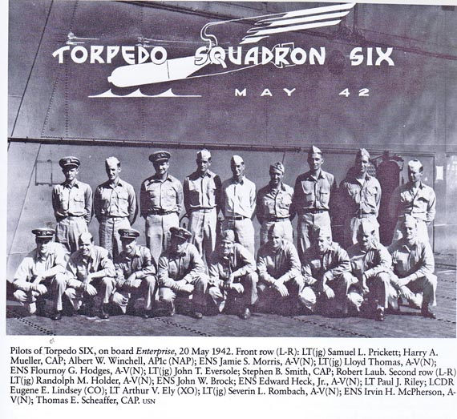States of America takes pride in presenting the Navy Cross (Posthumously) to Lieutenant, Junior Grade Lloyd Thomas (NSN: 0-81617), United States Navy, for extraordinary heroism in operations against the enemy while serving as Pilot of a carrier-based Navy Torpedo Plane of Torpedo Squadron SIX (VT-6), attached to the U.S.S. ENTERPRISE (CV-6), during the "Air Battle of Midway," against enemy Japanese forces on 4 June 1942. Participating in a vigorous and intensive assault against the Japanese invasion fleet, Lieutenant, Junior Grade, Thomas pressed home his attack with relentless determination in the face of a terrific barrage of anti-aircraft fire. The unprecedented conditions under which his squadron launched its offensive were so exceptional that it is highly improbably the occasion may ever recur where other pilots of the service will be called upon to demonstrate an equal degree of gallantry and fortitude. His extreme disregard of personal safety contributed materially to the success of our forces and his loyal conduct was in keeping with the highest traditions of the United States Naval Service. He gallantly gave his life for his country.
Two of the models of the Devastator TBD from my collection. The right one has markings of 6 -T-4. The left has yellow paint scheme of a plane assigned to the CV Lexington.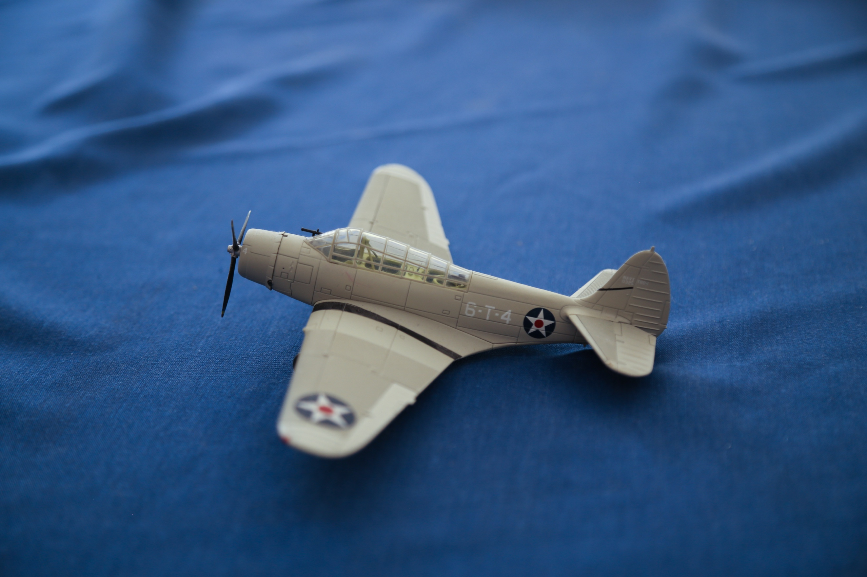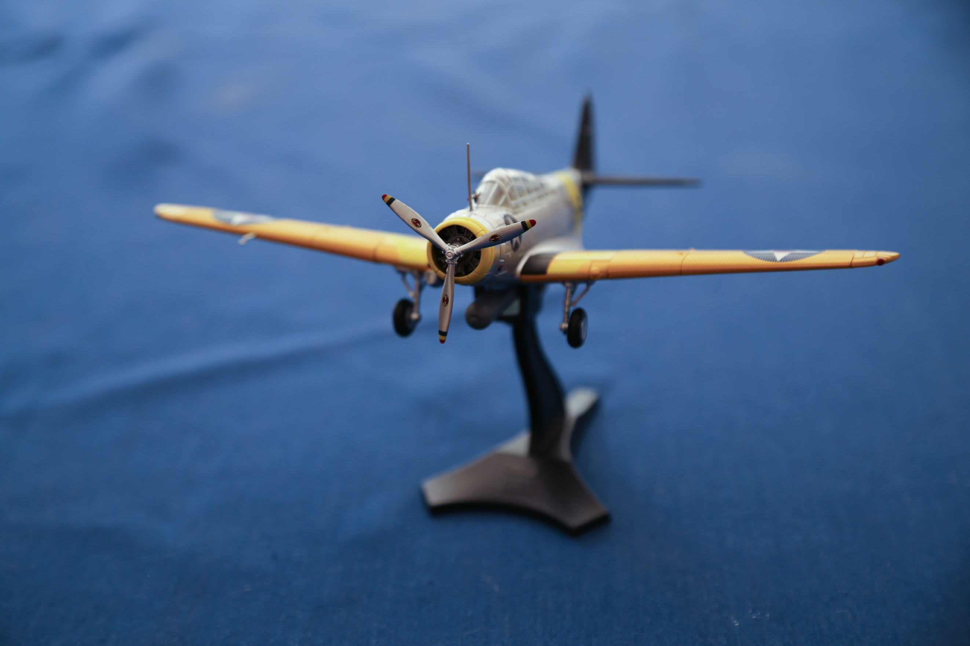
6-T-7 was the designation of the Thomas/Littlefield TBD. The 6 represents the ship (CV-6, the Enterprise); the T represents that it was a torpedo bomber (other designations were D for dive bomber, and S for scout, which were the fighter planes and served as the “air cover” for the ship, and 7 meant it was the seventh plane in that torpedo group. The following is a well know photograph of a Devastator from the Enterprise. Note the fuselage marking, “S-8”. This meant that it was “scout (or fighter) 8”. Also note that the 6 has been removed. The navy recognized that it would be better to not have an indication as to which carrier the planes came from, which might alert the Japanese to the type of carrier and perhaps the strength of the battle group. Later all designations were removed. In the picture posted in the previous note, observe that the plane designation is 6-T-4. 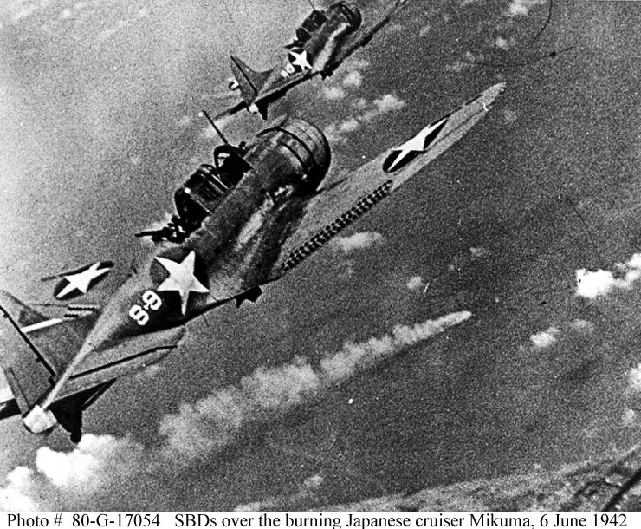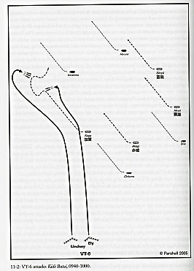
In an anvil attack the attackers split into two groups and attack the enemy’s ship from both the port and starboard sides, hence dividing the defenses in order to defend both sides of the ship. See above right. You will note that the Japanese Carrier force was in a loose “box” formation and heading to the northwest, away from the attacking planes of VT8 and VT6. Lindley split his Devastators into two groups of seven, he taking the longer tack and his XO Ely taking the starboard tack.
The Bureau of Medicine and Surgery, Navy Department, Certificate of Death of Aug. 7th, 1943 notes the following. Original admission: Torpedo Squad. 6 USS ENTERPRISE, date June 5, 1943, place: Pacific Area: cause of death: Killed in action, details not known. Death is in the line of duty. Disposition of remains: NOT RECOVERED. A summary of facts relative to the death: “This man was officially reported as missing in action as of 4 June 1942, having been a member of VT-6, based on the USS ENTERPRISE, when the plane to which he was attached was shot down in the Battle of Midway. The date of death for administrative purposes within the naval service was June 5, 1943. (Comment: for those missing in action or bodies not recoverable, the date of death is listed as 1 year later from the date of presumed death. This is because it is possible that the person might be a prisoner of war or somehow still alive but not in communication with the Navy.3-
Both are listed on the Honolulu Memorial at Punch Bowl Cemetery.
It is somewhat incongruous that the pilots (who were all officers were awarded the Navy Cross, a higher honor. Some attempt was made to increase the awards of the DFC of the radiomen/gunners to the Navy Cross, but this was denied.

