Viking Rhine Getaway: June 7, 2023

I cannot comment on the part of your journey from Basel to the juncture of the Main River, with the exception of Strasbourg, France, which was part of our trip around France and not on our Rhine float-trip. It was near Frankfort where we left the Rhine to travel thru the Main to the Danube.

Note: the descriptions in italics are taken from the Viking “Rhine Getaway” website.

Caveat: You will note that the trip is heavily sprinkled with wine and beer tastings. Hence, for a teetotaler, one needs to be quite circumspect in the choices of the excursions one chooses.
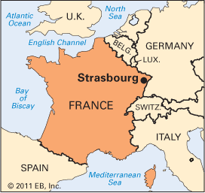
Strasbourg, France: Your cruise offers several included tours of Strasbourg, as follows: Disembark this morning for your guided tour of Strasbourg. See the European Parliament and tour the interior of the city’s famed cathedral. Free time allows you to further explore this Alsatian city’s blend of French and German cultures, resplendent churches, medieval covered bridges, verdant parks and handsome art nouveau and modernist architecture. Alternately, join our optional excursion into Alsatian wine country for an informative winery tour and tasting. Or, spend your full day exploring culinary Strasbourg on an optional excursion; as you explore the city and take in its sights, savor samples of the renowned Alsatian cuisine, from regional dessert specialties and meats to wine pairings with local foods. Return to your ship for dinner and departure. (Breakfast, Lunch, Dinner). (Comment: given the caveat above, the guided tour of Strasbourg might be of interest, particularly since it includes the interior of Strasbourg cathedral, but then, given my propensity for culinary adventures, the option for “regional desserts” sounds enticing.)

Strasbourg Cathedral
Strasbourg cathedral is an outstanding masterpiece of Gothic art. The construction of the Romanesque cathedral, of which only the crypt and the footprint remain, began in 1015. The spire of the current building, in a Gothic style, was completed in 1439. Described as "a skillful combination of monumental size and delicateness" by Victor Hugo, its facade offers a fantastic wealth of ornamental features. The 142 m spire is a masterpiece of architectural elegance and intricacy. Up until the 19th century, the cathedral was the highest building in the whole of the Christian world.
Discover three highlights during your visit: Viewed from the outside, the cathedral’s facade provides one of the finest picture books of the Middle Ages that you will ever see. The hundreds of sculptures which almost seem to leap out at you from the wall make great use of light and shadow effects. The color of the pink sandstone changes according to the time of day and the color of the sky. On summer evenings, the lighting effects around the cathedral are simply magical to watch.
Inside the building, the long nave provides the perfect setting for spiritual contemplation. The stained-glass windows dating from the 12th and 14th centuries form a particularly enchanting sight along with the rose window. The huge organ includes a remarkable case equipped with animated figures. The Renaissance astronomical clock, (the mechanism of which dates from 1842) is a masterpiece in its own right, and visitors can admire a parade by the apostles every day at half past noon. Below, my pictures: front façade with scaffolding, hopefully now removed. Right is the “laughing angel”

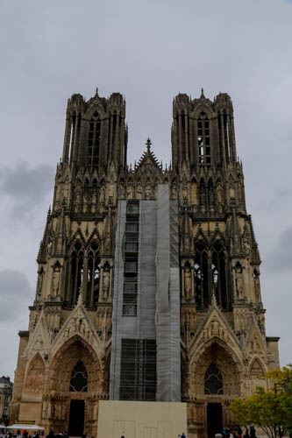 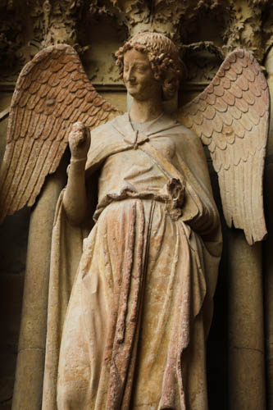 my pictures

Be sure to light a candle for Aleda.

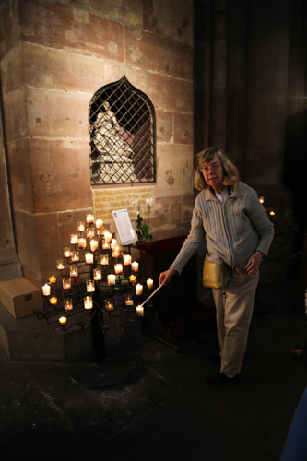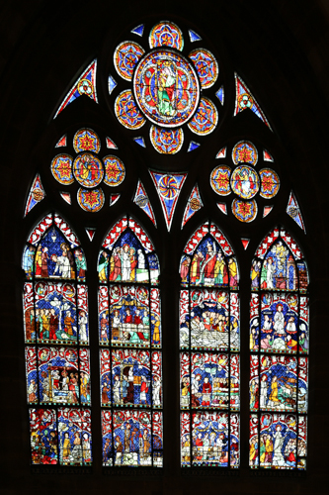
The first stop on OUR Rhine journey which we made similar to YOUR journey was at Rudesheim. Viking description:, sail the scenic Middle Rhine, a UNESCO World Heritage Site where turreted castles and fortresses overlook the river from their hilltop posts. Arrive in Rüdesheim in the late afternoon. Spend free time in the pedestrian-only Drosselgasse and sample a glass of locally produced wine at one of the restaurants or wine bars. Dine on board your ship, or in town if you prefer. You may also choose to experience one of our optional dinners on shore tonight. We depart after midnight. (B, L, D)

Jim’s comment: Of course the meals on board will all be excellent, and suited to the American taste and palate (especially the bacon), and provided three times a day, but…. The “but” is, to me, eating all of the onboard meals means that one never gets the culinary adventure of having a local meal at local restaurant. This deprives one of the experience of having to find a local restaurant and having to interpret the local menu’s language, assuming one doesn’t ask for an “English menu”. The disadvantage is that one has to do a little planning. I typically using the Michelin Guide and look for “BIB” restaurants, that way I know where I’m going and it would allow me to not miss the boat. Hence, it is my thought that if any of the excursions include a local meal off of the ship, that might be strongly considered.
Rose Garden, Rudesheim, Germany
My picture: 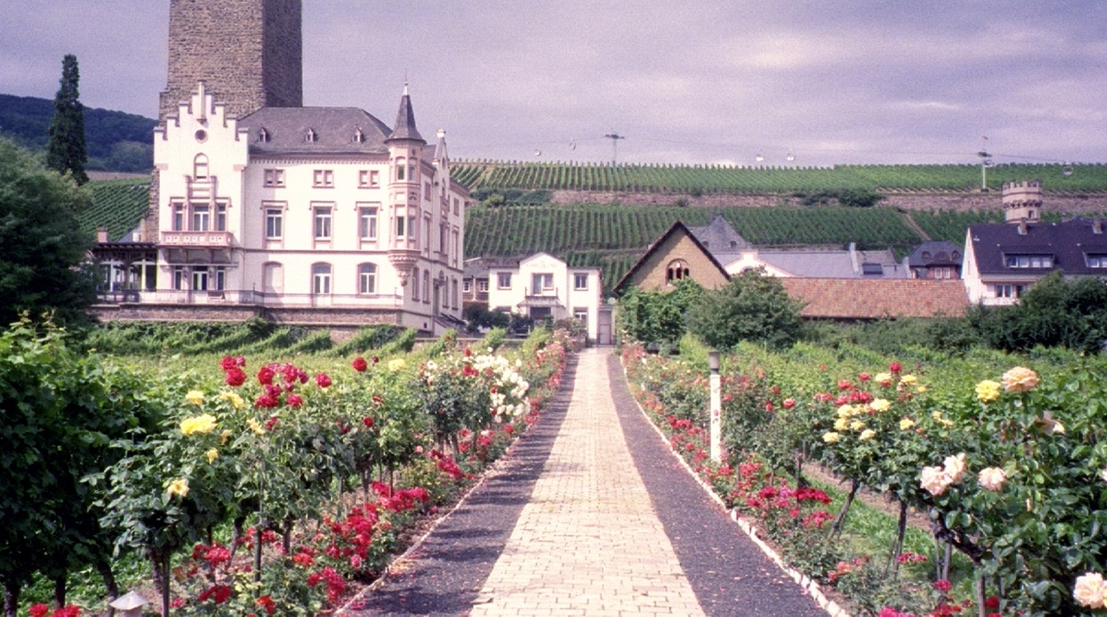
In the background is the Boosenburg / Oberburg, a Romanesque keep, next to the Broemserburg, the latter housing the wine museum. The shape of the building alludes to 9th-century origins. Standing 38 meters high, the tower of the Boosenburg is the town's tallest building. Nestled into these walls, which are up to three meters thick, is a castle-like residence. The entire complex is privately owned and, unfortunately, not open to the public. To the left, out of the picture is the Brömserburg / Niederburg. From the early 10th to the early 19th centuries it was the property of the archbishops of Mainz. They converted the old fortress into a residence in the 12th century. Originally, it was right on the bank of the Rhine, surrounded by water. Its more than two-meter-thick walls withstood all offensives. Only the southeastern portion was destroyed by the Duke of Longville. A mine path to the keep bears witness to its invincibility. After being secularized in 1803, the castle had several owners until the town of Ruedesheim purchased it in 1941. Today, it is the home of the vast collections that comprise the Rheingau wine museum. Historic wine presses from several centuries are displayed in the garden.
Rudesheim is one of the earliest towns in Germany to find its fortune in the tourist trade, excepting the towns on the Pilgrim routes traversing Germany or those involved in mercantile trade. See below for a history of Rudesheim’s tourist trade. Examples of museums in Rüdesheim: Rheingau Wine museum in Brömser castle, Medieval Torture museum, Roller museum, Siegfried's museum for mechanical instruments, the clock museum or the world famous brandy distillery. However, chief among the tourist attractions are the Drosselgasse and the Niederwald Monument. Drosselgasse: This narrow alleyway is 144 meters long and offers non-stop live music, dancing, and entertainment from late morning until well after midnight. You will meet people from all continents, enjoying wine and music in the wine bars and gardens of the most famous ally in the world. It is also non-stop curio shops and wine parlors.
Niederwald-Monument: The dramatic monument, nearly 38 meters high, built from 1877-1883 according to plans by Johann Schilling of Dresden, is no longer in vogue. It symbolizes the reestablishment of the German Empire after the Franco-Prussian War of 1870-71. The main figure is Germania, holding the imperial crown in her raised right hand and the imperial sword in her left hand. The heights of the Niederwald can be reached via cable car and chairlift from Ruedesheim and Assmannshausen, respectively. The fantastic view from the monument extends well into the State of Rhinland-Palatinate. The Niederwald monument also has an important connection to modern German history, for inscribed below the noble statue of Germania are the words of the nationalist song, “Wacht am Rhein”. See below

Koblenz: This was one of Aleda’s favorite towns. It is situated where the Moselle River flows into the Rhine. Hence, Chris will have opportunity to sample wines from the Moselle valley and the Alsace region.
The Viking excursions are:
This morning, sail along the most scenic stretch of the Rhine, where turreted castles and fortresses overlook the river from their hilltop posts. A UNESCO World Heritage Site, this part of the Middle Rhine Valley is so beautiful. Arrive in Koblenz this afternoon and disembark for a guided exploration of Koblenz on foot. You may also join an optional excursion that offers a lively and informative tour of Ehrenbreitstein Fortress; or, choose to journey into Moselle wine country on an optional excursion, stopping for a tour and tasting at a local winery. Return to your ship for lunch. Later, enjoy some time in this charming town at the confluence of the Moselle and Rhine Rivers. (Breakfast, Lunch, Dinner)

Cologne (Koln):
Begin your day with a morning tour of Cologne, Germany’s fourth largest city. Stroll through Old Town past St. Martin’s Church and see the Dom, Germany’s largest cathedral and a UNESCO World Heritage Site. Spend your free time enjoying Cologne’s atmospheric waterfront, or perhaps join an optional excursion on which you ascend to the Dom’s roof for up-close views of the cathedral’s architecture and bird’s-eye vistas of Cologne. Afterward, return on board for dinner. Alternately, you may set off on an optional excursion to explore Cologne’s spirited beer culture, sampling Kölsch, a light, crisp beer brewed only in Cologne, and enjoying a brauhaus dinner. After, return to your ship for a late-evening departure. (Breakfast, Lunch, Dinner)

Comment: There’s not a heck of a lot to do in Cologne except the cathedral. Well, that’s not quite true but the other things are mostly museums and they won’t likely be taking you to many of those in the guided tour excursions from the boat. Cologne is a busy city so watch where you step.
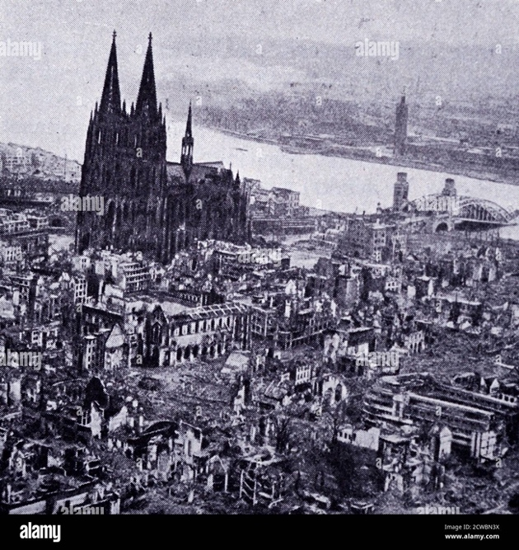
Comment: The monumental object in Cologne is the “Dom”. It will no doubt be pointed out that there is a difference between a “Dom” and a “Cathedral” and a Basilica and a Munster. “They are quite similar, but the etymology is different. A "Kathedrale" is a church of a bishop's see. "Münster" and "Dom" not necessarily, like the Ulmer Münster and the Petersdom (St. Peter's basilica) the bishop’s church. "Dom" comes from Latin "domus dei" - "house of God". "Münster" was derived from Latin "monasterium" - monastery. In English, it formed the word "minster" (at least in British English). Basically, most churches simply have their names and there just happen to be 3 names for bigger churches. When you talk about churches in general, you still call them "Kirche", sometimes "Kathedrale" if you want to stress that it's a monumental building. So this should answer the habit part of your question. In everyday talking, people might even call a "Dom" or a "Münster" a "Kathedrale" - just because this is the most common word.
Left is a famous picture of the “Cathedral” in Cologne after WWII. The bombing campaign tried quite hard to avoid hitting it and were generally successful. Otherwise the city was pretty well destroyed. To the right you can see the Hohenzollern bridge, which was destroyed by the Germany engineers as they retreated across the Rhine as the Allied armies attacked.

Things important to me. Along this portion of the middle and lower Rhine are two bridges that are important to the student of World War Two, and you will pass under them but it is unlikely that they will be mentioned and there will be not excursions or stops or even slowing the boat down. Travelling south is the Bridge at Remagen. It is between Koblenz and Bonn.my picture.
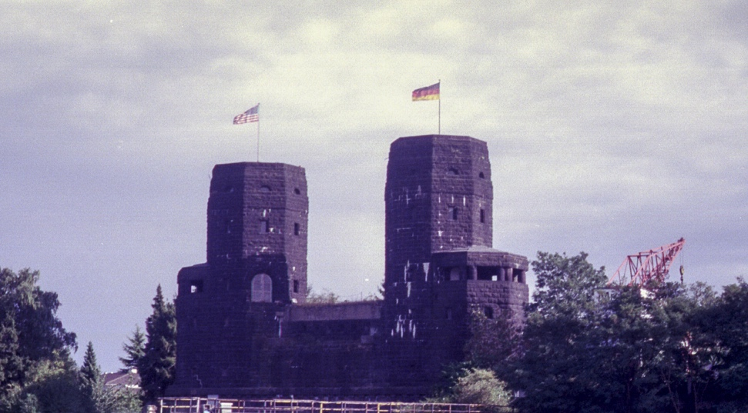
The only thing that remains of the original bridge are the two, twin towers that stand on the western end of the river. The Remagen bridge is the only bridge that was not demolished by the Germans as the Allied armies approached the Rhine, and this was by a rather grievous error on their part. Capturing it intact allowed the American Third Army to secure a foothold on the Eastern bank of the river and then expand into heartland of the Reich. Uncle Adolph was not happy when he heard about its capture.
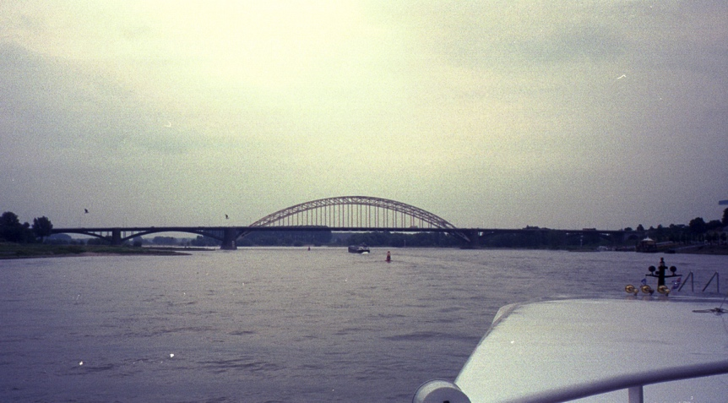
The second bridge is the Nijmegen bridge, however, this is over the Waal, and not the Rhine and so you may not pass under it, depending on how the boat is travelling to Kindersdijk. This bridge was an import battle site for Operation Market Garden, although it is NOT the eponymous bridge in “A Bridge Too Far”. I won’t dwell on this any further.
My pictures.

Amsterdam.
If your schedule permits, you may wish to visit the Rijksmuseum, or the van Gogh Museum next door. (Dinner).
Comment: It is almost imperative to visit one or both of these museums. The former has Rembrandt’s The Night Watch, a monumental piece of the Northern Renaissance. The van Gogh museum, which we have not been to, is also amazing. Or so our friends tell us. They are practically right next to each other. If one had to choose between the two, I guess it depends on one’s taste in art.

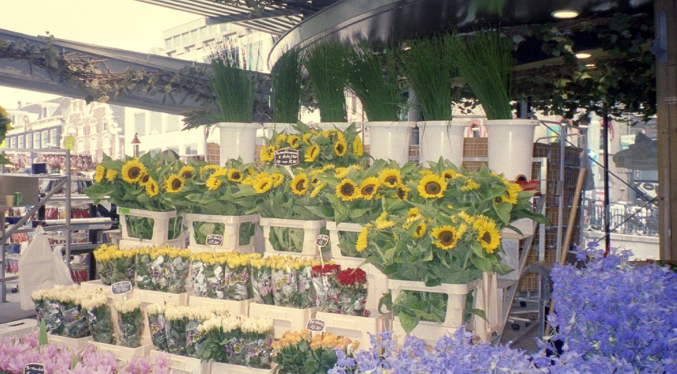
Located on the south side of the Singel Canal, the Bloemenmarkt is the world's only floating flower market. This incredible fleet spans four blocks, hundreds of stalls on moored barges selling exotic blossoms, bulbs, and potted plants at very low prices.

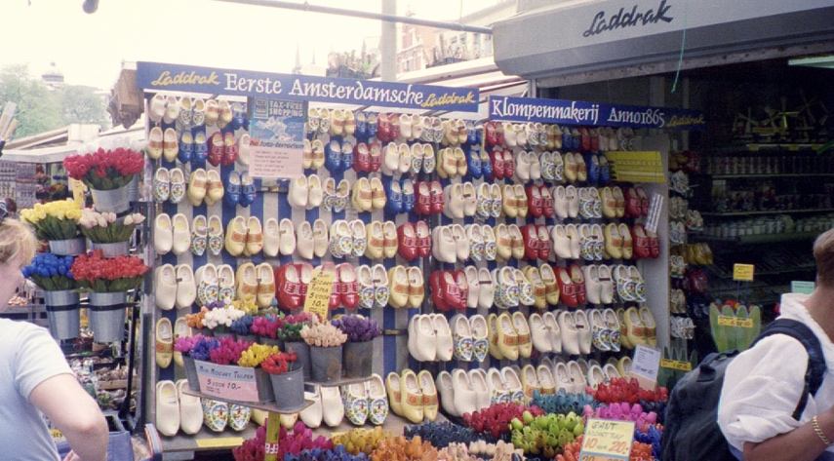
Clogs or wooden shoes have a long social history. The Klompen or Dutch clog was traditionally a work shoe worn in the Industrial Revolution. The style was also popular in northern France, England, Belgium, Luxembourg and the Netherlands. Clogs were cheap and durable made from alder, birch, sycamore, willow or beech. When worn barefoot, thick straw was used to pad the rigidity of the wood. The upturned toe made the shoes easier to walk in. The French, Sabot; the German, Klomp, and the Dutch, clog were made from a single block of wood whereas the Spanish pantofle and later US and UK clogs were constructed like shoes with a separate wooden sole/heel from the leather upper. Although clogs and wooden soled shoes have had brief moments in fashion, they were the traditional footwear of the poor and those work necessitated heavy-duty shoes.

Another name for the klompen is the sabot, which is the French word that literally means, “wooden shoe.” Our word sabotage is said to have derived from this word because during the late 1800s and early 1900s many workers in labor disputes would bring their sabots to work with them and throw them into the machinery of their employer. This would clog the machines, and shutdown the factory, usually for several hours. Other descriptions of the origin of the word sabotage have a more agricultural derivation, such as the workers trampling down the crops with their klompen or sabots.

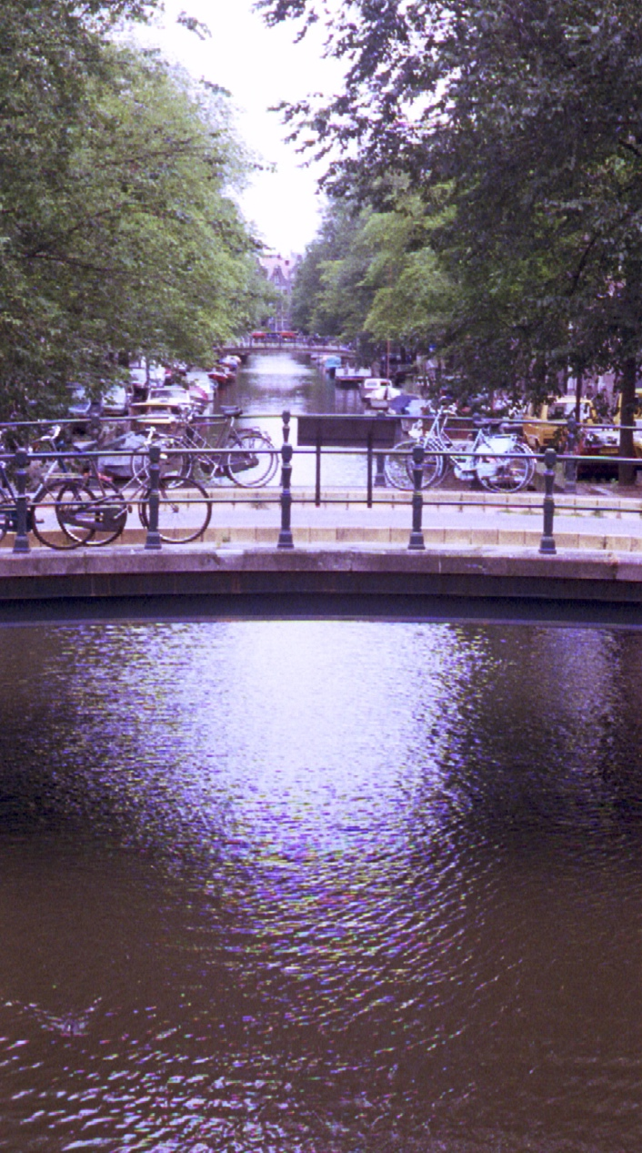
Houses and Canals, the Jordans, Amsterdam, Netherlands
View across Prinsengracht down at the Blumengracht
my picture
View across Prinsengracht, down the Blumengracht Canal.
To your rear (not seen, you have to turn around) is the Anne Frank house/museum and the Westerkircke with its famous bell tower.
Amsterdam is not a city of churches and palaces, but of monumental mansions. The area is called the Jordaan. The name 'Jordaan' probably comes from the French jardin (garden), and many of the streets are named after flowers. Traditionally a working-class area, built to the west of the city center in the 17th century, it now is one of Amsterdam's oldest and loveliest quarters. With it's cosy streets and narrow canals wandering through the Jordaan is a pleasure on its own, especially since here you will find some of the city's best shops, cafes and restaurants. Another part of the Jordaan's charm is what is hidden from the uninformed eye: the area has the highest concentration of hofjes (hidden garden court-yards) in Amsterdam. The Jordaan is one of the most charming neighborhoods in a city that defines charm. This picturesque cluster of narrow streets and canals dates from the 17th Century, when it housed not wealthy merchants but immigrant workers. Around the Jordaan you will see many famous sights, including the house where Anne Frank wrote her famous diary. The Westerkerk was planned to cater for the religious needs of the inhabitants of the northern section of the ring of canals and was built on a site adjacent to the Jordaan area. The Jordaan, one of the most colourful and popular of Amsterdam neighbourhoods, soon developed a special relationship with the tower of the Westerkerk (completed in 1638). The ‘Old Wester Tower’, is the subject of the lyrics of many popular songs to the point where more or less human characteristics became associated with this familiar building. In her diary, Anne Frank has a special affection for the bells of the Westerkerk, since it brought some sensory stimulation from the outside world.

EXTEND YOUR CRUISE WITH 2 NIGHTS IN AMSTERDAM

Comment: A nice way to see the city is through a canal boat ride. Here are a list of boat tours: https://www.viator.com/Amsterdam-tours/Canal-Cruises/d525-tag21709
Navigate Amsterdam’s picturesque canals while discovering its cultural and architectural treasures. Witness the legacy of the Dutch Golden Age that lives on in the city’s gilded manses and stroll through the Jordaan district, passing historic sites such as Wester Church and the Anne Frank House.
Note: The Anne Frank House is very popular. If you plan to visit it, we advise purchasing your tickets well in advance online at the museum’s website.
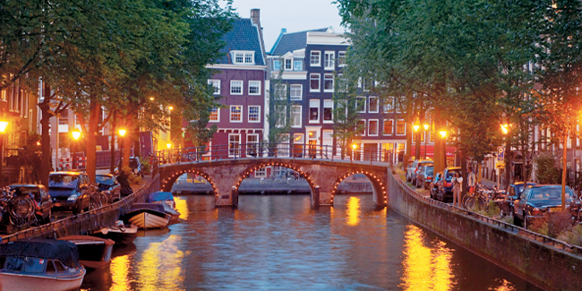
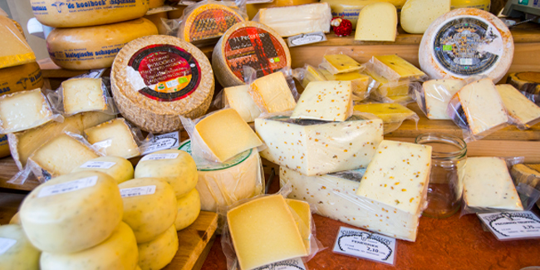
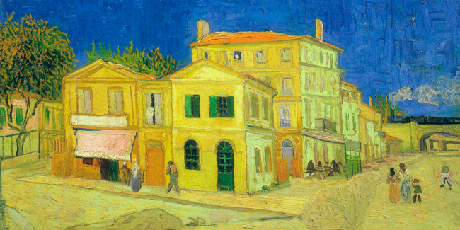
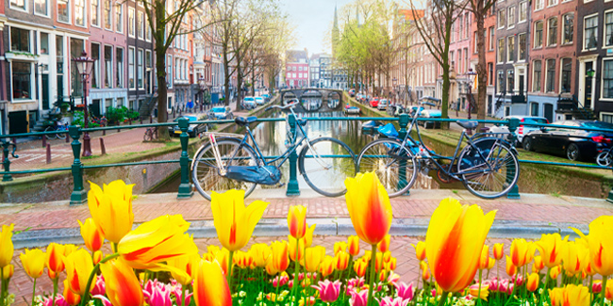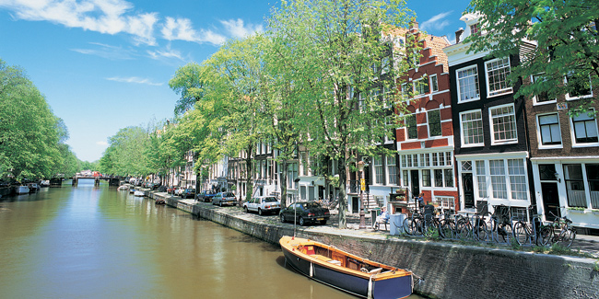

Amsterdam Extension: city of bicycles & tulips
Dutch painting, Rijksmuseum, Amsterdam

Day 1 - Amsterdam
Welcome to Amsterdam. Transfer from the airport to your hotel. The rest of your day is at leisure to explore Amsterdam’s charming neighborhoods and sample some treats. A Viking Host is available to help you plan your time in Amsterdam so you can make the most of your visit.
Canal cruises are a relaxing way to see the city

Day 2 - Amsterdam
After breakfast, embark on a walking tour through the charming streets of Amsterdam. Your afternoon and evening are free to enjoy Amsterdam’s wonderful restaurants and many attractions; explore the city’s art or historic museums; or take a stroll along the picturesque canals. This evening, dine in a local restaurant—Amsterdam offers many establishments in the “grand café” style and is also known for excellent Indonesian cuisine—and enjoy the city’s lively nightlife. (Breakfast)
Dutch clogs, Amsterdam

Day 3 - Amsterdam
Today, you have additional time for touring or shopping. Later this afternoon, transfer to your ship to begin your river cruise. (Dinner is served on board your ship as part of your cruise itinerary.) (Breakfast)

A History of Tourism in Rudesheim 1693 The Niederwald was bought by Count Ostein. He subsequently built the castle (now Jagdschloss Niederwald) and transformed the Niederwald into a fantastic spacious park area - including the view points "Temple, Eremitage, Rossel, Rittersaal and Zauberhoehle". He opened this all to the public aud subsequently laid the foundation for one of the main attractions for tourists all over the world. 1813 Michael Dominikus Meurer opened the first guest house in the Drosselgasse, named DROSSELMUELLER. 1825 the Rheinstrasse was build and the first steamer came from Cologne via the Binger bend. 1837 The Duesseldorfer Rhine steamer took up regular service on the Rhine and docked in Ruedesheim. 1843 Boat trips were available everyday from Strassbourg and everyday from London except Mondays. Thomas Cook was the first Travel Agency to book into Ruedesheim. 1866 There were too many wine drinking places in Ruedesheim. Therefore it was decided by the community council that only nine winegrowers would be allowed to serve. 1868 A police order was given to tourist guides for renting wagons, horses and donkeys. By this time the famous Niederwald could be reached by coach with a regular timetable. 1870 At this early date Ruedesheim was known as the "Pearl of the Rheingau region" and it was the main tourist attraction. In the high season up to 100 people arrived everyday by ship. 1871 the Wiesbadener spa director Ferdinand Heyl proclaimed the Niederwald to be one of the most wonderful view points in Germany and suggested to build the Germania statue there. 1873 it was finally decided that the Niederwald would be the place for the statue. Until the laying of the foundation in 1877 the roads were build and plastered in Ruedesheim. 1878 in order to avoid confusion with Ruedesheim on the Nahe - the cityname "RUEDESHEIM AM RHEIN" was decided upon. 1883 the Niederwald monument had its inauguration. 1884 the first cable car goes up to the Niederwald. 1885 the work is taken up for a second cable-car from Assmannshausen to the Niederwald monument. At that time 'Mass tourism" began to Ruedesheim am Rhein. 1904 the tourist association was formed. It had then 118 members, today it has 319. Already speedboat from the Koeln-Duesseldorfer shipping compmy travelled on the Rhine, it was advertised in Germany and foreign newspapers, it was negotiated with the railways to connect special trains with Ruedesheim, but also complained because of the impossible health damaging fumes which the steam trains released when passing. 1906 There were two tourist associations between Mainz md Cologne - one in Koenigswinter and the other in Ruedesheim. 1927 the first tourist office and youth hostel opened. From 1930 there were three guesthouses. It was during this time that many of the famous Rhine songs became popular. 1932 Ruedesheim celebrated it's first wine festival
Wacht am Rhein: Die Wacht am Rhein (Watch on the Rhine) is a German national song written in 1840 by Max Schneckenburger and composed in its popular form in 1854 by Karl Wilhelm. It was the battle-song of the German army in 1870 to 1871. However, it remained an important marching/patriotic song for the German army both in World War I and II. The phrase “Wacht am Rhein” became synonymous with German Nationalism, and was associated with the Rhine River as the sacred western border of the German nation. Liedtext: Die Wacht am Rhein There are three other references to “Wacht am Rhein”. - This was the German code name for the Ardennes offensive in 1944, which the American’s call the “Battle of the Bulge”. - The tune to Wacht am Rhein is also the tune for the famous unofficial Yale alma mater composed in 1881, “Bright College Years”. The song fell from grace in the aftermath of World War I when anti-German sentiment nearly caused "Bright College Years" to be banned from campus. The original words to Die Wacht am Rhein were written in 1840 when France threatened the left bank of the Rhine. In 1854, Carl Wilhelm set the poem to his music and played it for the silver anniversary of the Crown Prince of Prussia, later William I. Its popularity grew during the Franco-Prussian War of 1870-71 and beyond. During World War I, the German national song became so hateful to the Allies that the English wrote a rejoinder, "When We've Wound Up the Watch on the Rhine." Yale men stationed in Paris began singing "Bright College Years" to the tune of La Marseillaise, and after the war, many students and alumni told the administration that they could no longer sing the German air in public. From: http://www.yalealumnimagazine.com/issues/99_12/old_yale.html 3) The song appears in the movie classic Casablanca. Casablanca, set in northern Morocco, is Vichy French territory early in World War II, and nationalist tensions run high among Rick's French, German, Italian and American customers. Lazlo's presence only aggravates an already tense situation. In the famous scene, he inspires the band at Rick's to drown out the Germans (who are rigorously singing "Die Wacht am Rhein") with "La Marseillaise".

