The Old Switcheroo (translation to Swedish: Högertrafikomläggningen)

If you’re old enough, think back to September 1967. And if you were in Sweden in that year, think back to early September, specifically Saturday and Sunday September 2nd and 3rd. On the former day you were driving on the left side of the road and on the latter you were driving on the right. This transition, which actually took place early in the morning of the 3rd, was called “Högertrafikomläggningen”, literally “the right-traffic reorganization”. This was abbreviated to Dagen H (or H-day). This was the largest logistical event in Sweden’s history.
This was not the first attempt to order traffic to be moved to the right, which was in 1718, however, by 1734 regulations stipulated Swedes should travel on the left. This didn’t matter much in those days because traffic was sparse but its Nordic neighbors, Norway and Finland, had already made the change. Most other European countries were driving on the right with the exception of the United Kingdom since the time the Common Market was organized in 1958. Saab and Volvo were starting to make some models with left-hand steering. In fact, most Swedes (90%) drove left-sided steering vehicles because many American and German cars were imported into Scandinavia.


The Swedish Government (Riksdag) had been promoting the change to the right since 1927 but in a 1955 referendum, 83% voted to stay on the left. However, ignoring the plebiscite, in 1963 the Parliament approved the prime minister’s proposal for right hand traffic beginning in 1967. A commission was established to initiate a four-year educational program. This program included wide-spread public service announcements and the Dagen “H” logo which was widely distributed and even appeared on underwear and milk cartons.
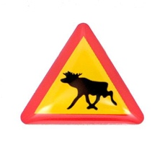
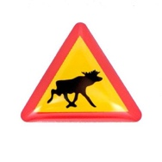
As Dagen H approached extensive changes were made to signs and road markings. Intersections were equipped with extra poles and traffic signals were wrapped in black plastic. Early in the morning of H-day, the plastic was removed. Existing road lines were yellow, so before the changeover, white lines were painted and covered in black tape that could be quickly removed. About 350,000 road signs were removed or replaced. Some signs were mirrored such as indicating a moose crossing because it was felt that the moose were more likely to come from the right-hand side of the road. [Comment: whether there was a moose re-education program is not certain, though given Swedes thoroughness, I’m sure there was.]
On Dagen H, all non-essential traffic was banned from 1 in the morning to 6 am. All vehicles had to stop at 4:50 am and then change to the right side of the road. At that minute, the radio announced “Now is the time to change over”. In Stockholm and Malmö, the ban was extended from Saturday 10am to Sunday 3pm so that workers could reconfigure intersections. Over 10,000 police and 100,000 volunteers were utilized. Every Swedish car had have their headlights readjusted so that at the low level the beams shown to the right rather than the left. No fatal traffic accidents were felt related to the switch.
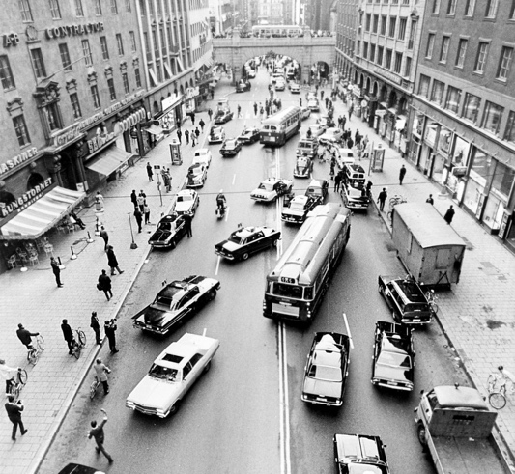
Public transport such as trams and busses were more difficult to adjust. Many trams were replaced with correctly manufactured busses but 7,500 busses were converted from left to right boarding. This modification was the largest cost of the transition. The cities of Gothenburg and Malmö sent their busses to Pakistan and Kenya, where the British model existed (and still does). Stockholm already had bi-directional trams with doors on both sides of the vehicle.
The results? Well, they’re still driving on the right side of the road. In the short term traffic accidents and fatalities went down but by about six weeks had returned to pre-H levels. This was felt likely due to drivers (and pedestrians) being extra cautious after H-day. So, the moral is, with a firm decision and good public planning a major public change can be made. Above: Kungsgatan, Stockholm on Dagen-H (public domain).

From: Little Car see https://www.youtube.com/watch?v=h6RWrzRF8Fc and see: Wikipedia Wikipedia contributors, "Dagen H," Wikipedia, The Free Encyclopedia, https://en.wikipedia.org

