How well do you know Jim Littlefield? or The Vanity Game
1. Name this object, what year was it acquired?
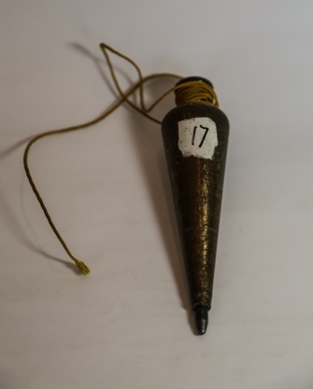
Ans: Plumb bob: A plumb bob is used to establish a vertical line, used frequently in surveying as well as carpentry and masonry. In the summers of 1963 - 1965, Jim worked as a surveyor's assistant in the Survey and Design Unit of the Department of Streets of the City of Philadelphia. The first year, he began as a "chain-man", the next summer worked as a "rod-man" and the last as a "transit-man". It was a job his father found for him to keep him occupied in the summers while at college. His father worked for the Department of Streets in the Street Lighting Division. Each of the three years he worked in a different District within the city and came to know several areas of Philadelphia quite well. Importantly he also learned to play pinochle and they had some good volleyball games at lunch time.
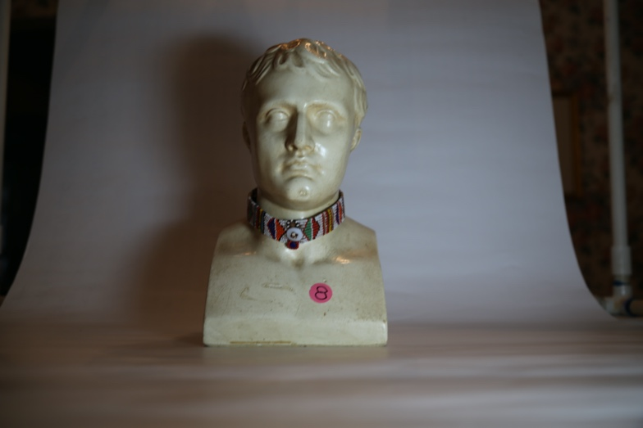
2. Name the person depicted in the bust and the origin of the "choker".
Ans: Napoleon Bonaparte and the Massai tribe in Africa. Jim's Great-Aunt Cecilia, a notable figure in the family history, who was an author and a "working-woman" at a time when this was the exception rather than the rule (she was a secretary to several well-known physicians in Philadelphia in the first half of the Twentieth Century and worked in the Juvenile Court system). Her strong personality admired other strong personalities, such as Napoleon Bonaparte and Benito Mussolini. The choker was obtained from a Massai warrior by Jim on their trip to Kenya in 2004.
As is the custom on these tours, we were taken to a Masai village, somewhere in the Masai Mara (a large game preserve in Kenya) and there they had plenty of souvenirs laid out on their colorful cloaks on the ground. There were some Masai men in their traditional garments. One particularly caught my eye and particularly his necklace or choaker. So he asked me if I wanted to buy something and I pointed to his beaded necklace. We established a price, I forget what it was, and he took it off and we exchanged the object and money. As noted above, I keep it around the neck of Napoleon.
3. Name who these two people are and where they are.
Ans: Aleda reclining on the funerary stone at Machu Picchu in 1969 as part of their tour of South American during their time in the Peace Corps. The funerary stone on which she sits is in close proximity to the cemetery where many skeletons were found by Hiram Bingham. Jim is sitting on the stone called
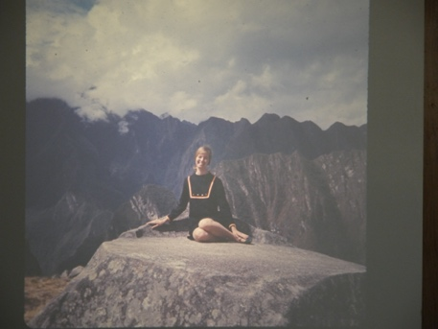

Inti Watana which is believed to have been designed as an astronomic clock or calendar by the Incas Hence inti watana is literally an instrument or place to "tie up the sun", often expressed in English as "The Hitching Post of the Sun". The Inca believed the stone held the sun in its place along its annual path in the sky. At Midday on 11 November and 30 January the sun stands almost above the pillar, casting no shadow at all. On 21 June the stone is casting the longest shadow on its southern side and on 21 December a much shorter one on its northern side.
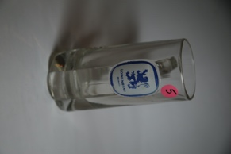
4. Name the object and where was it "acquired".
Ans: Lowenbrau beer stein "acquired" at the West German pavilion beer garden restaurant in Flushing Meadows at New York World’s Fair, summer of 1965. This was the first of the many trips that Aleda and Jim took together. The next trip after this was the Montreal Expo of 1967. This was about a year before we were married. We drove our (Aleda’s) new (she bought it in Camp Hill during her first job teaching there, replacing the old Ford convertible which she had at college) Plymouth Barracuda to New York and slept in the back in sleeping bags because there was no room at the inn.

5. What's an Ortlieb's beer can got to do with it?
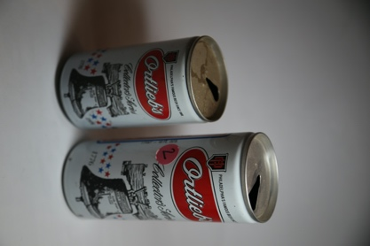
Ans: Commemorative Ortlieb's beer can from 1976. Jim's mother, Kathleen Walsh, had a first cousin, (son of his Mother's (VIctoria Flick Walsh) brother (Edward - or Uncle Ed), Manuel (or Uncle Manny) and his wife, Aunt Flora. Uncle Manny only did a few things successfully in his life, and one was to marry Helene Ortleib, the daughter of Joe Ortlieb, owner of Ortlieb's beer, a local brewery in Philadelphia. Henry Ortlieb purchased a local brewery in 1893, and after some difficult years during prohibition, eventually did well as a local brewer, perhaps peaking around World War II. Local brewers were eventually swallowed up by the major breweries and Ortlieb's is now produced in Baltimore by an Austraian firm. The other thing Uncle Manny did well was to tell jokes (and ribald ones at that) and throw a good party at their house in Villanova. It was always a good time at their house parties, espcially after imbibing the Fishhouse punch.

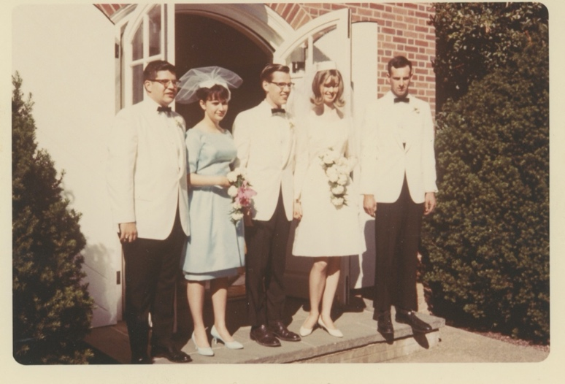
6. Who are these people, where were these pictures taken and in what year?
Ans: Wedding pictures from June 11, 1966, after the marriage of Jim and Aleda. Location is Eisenhower Chapel, on the Penn State University campus, in State College, Pennsylvania. Also pictured is Aleda's brother, John, who gave away the bride. Aleda's father had died in 1963? Officiant was Father Quentin Schaut. OSB. Left to right: Beal Traister, best-man; Jean Tomko, maid-of-honor, Jim Aleda, John Litzel.

7. Where was this photo taken, and when, and who are these children and the nun? Can you identify any of these children?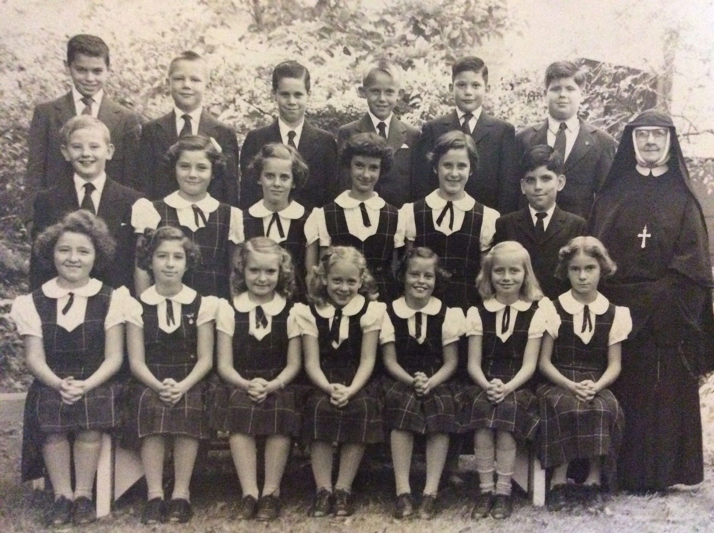
Ans: The annual 4th Grade photo, taken in the garden at St. Leonard's Academy, in the spring of 1954, 39th and Chestnut Streets, Philadelphia, PA. Pictured are his fourth grade classmates and Sister Maria Rita, Sisters of the Holy Child. Of note are the suits and ties on the boys, and ties were required every day, and the plaid uniforms of the girls, also a daily requirement. Fourth grade was the last grade that was "coed" with boys and girls. After this, Jim didn't have girls in his classes until he attended College eight years later. This is probably why women appear so enigmatic to him. Jim is the second boy from the left, standing, back row. Beginning in the back row: L to R: Tom Colucci, Lan Littlefield, Gary Eggeville, Frank Hagan, Bob Trojan, Joe Holden, Ed McGowan (dec.), Suzanne Manika, , Eileen McGuckin, Cathy Crescenta, Jacque Drobel, Pat Rosle, Sr. Maria Rita, Cheryl Felz, Doreen Ferraro, Carol Morgan, Maureen Geckle, Susan Murray, Carol Anne Meade, Judy Fasciott.

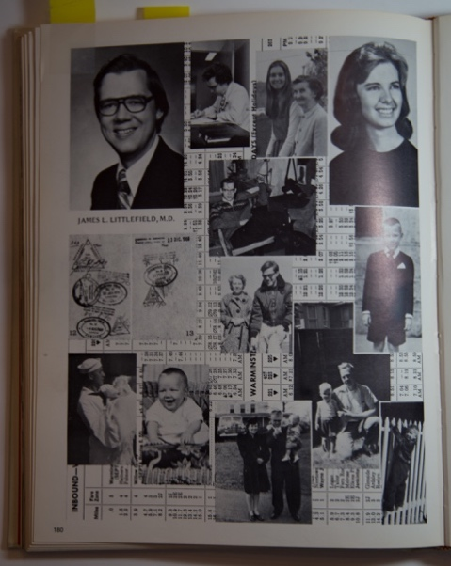
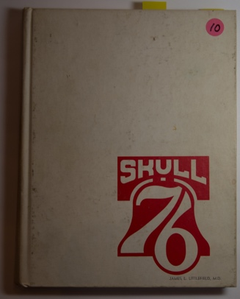
8. What book is this? Note Jim's page:
Ans: Temple Medical School Yearbook, class of 1976. Jim was the editor of the annual publication of "Skull", the Temple University Medical School Yearbook, for 1976, the year of the Philadelphia Bicentennial celebration, hence the Liberty Bell logo on the cover. Each graduate had the opportunity of create their own page design. Notice Jim's collage of photos and memorabilia. In the background of the page is the time-table of the Hatboro local commuter train that Jim took most days from their house in Bucks County to the North Philadelphia station near the Med School.

9. Why is there a vinyl record album here and what is its significance to Jim?
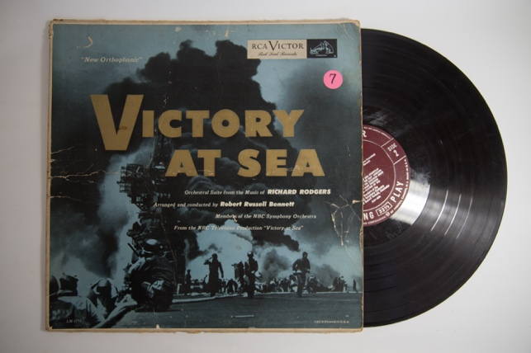
Ans: This "Victory at Sea" vinyl record album is the first record album purchased by Jim, probably purchased about 1954. A record player was also purchased by his mother to play the album, a Philco if I remember correctly, with both 45 and 33 1/3 record speeds. This was a collection of music from the TV series "Victory at Sea" describing the naval war in both the Atlantic and Pacific during World War II, based upon themes by Richard Rogers and composed and orchestrated by Robert Russell Bennett. The significance is that: a. it probably served as Jim's introduction to and interest in classical music, which continues to this day (also with Aleda) and b. it's indicative of Jim's early interest in World War II, which also continues to this day (see the collection of WWII books in the “green room”.)
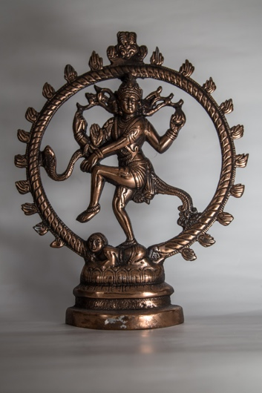
10. Who is this?
Ans: This is a statue of Shiva Nataranja. This is a depiction of the god Shiva as the cosmic dancer who performs his divine dance to destroy a weary universe and make preparations for the god Brahma to start the process of creation. We'll avoid Indian mythology for the moment, although it was Robert Oppenheimer who described the first atomic bomb explosion as "Shiva, the destroyer of worlds", and merely note that one of the medical residents (Dr. Puli) that Jim trained at St. John's gave him this statue as a token of thier time together and their discusssions of Indian philosophy.

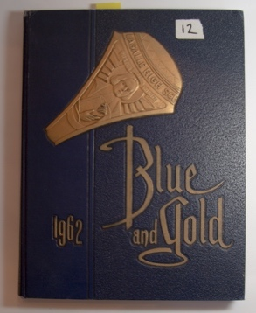
11. What book is this?
Ans: LaSalle College High School Yearbook, class of 1962. Note Jim's page. JIm was a co-editor of the year book. Below his picture is noted: his address, parish, zipcode, and the various and multitude of activities in which he participated from 1958-1962. Note the paucity of sports activities, although LaSalle was a well known sports powerhouse. LaSalle was run by the Christian Brothers. Other activity pages are marked. The class which he hated the most and which profited him the greatest was Typing with Brother Raymond. The class which he liked the best and profited the least was either English IV (Mr. Moore) or POD (Problems of Democracy (Br. Adrian).

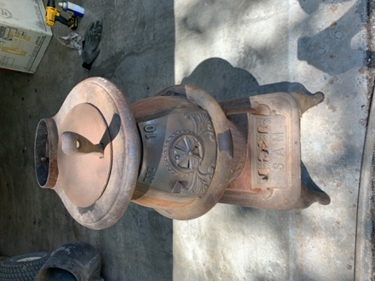
12. What is the "familiar" name (sobriquet) of this object.
Ans: "Little Sam". In 1949 or 1950 the family (Jim's parents and his uncle Jim and Aunt Mary Frances Walsh) purchased a summer house - called "the Cottage" on the Eastern Shore of Maryland, on Grove Point. It was quite remote, and without electricity or water supply at that time, hence the numerous "out-house" stories mirthfully told by the family. "Little Sam" was purchase to provide heat (and a source for boiling water) until a propane stove and a kerosene heater were purchased sometime later.

13. What are these and where did they come from and when?
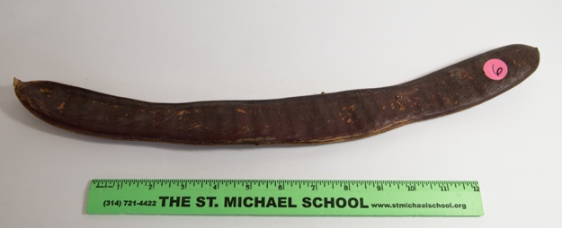
Ans: Poinciana bean pod and steel drum. Aleda and Jim joined the Peace Corps together, having been married for two ears, in 1968 and served in Jamaica for two years. Aleda was involved in early childhood education and teacher training. Jim was involved in mathematics curriculum reform and later teaching general science, as with Aleda, at the Mico College in Kingston, Jamaica.

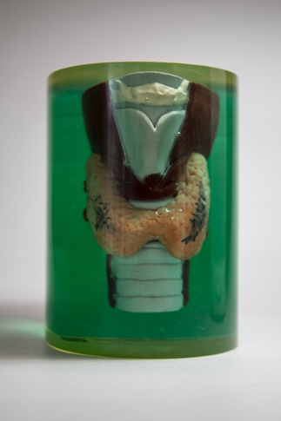
14. What is this? What is its function?
Ans: This is a thyroid phantom. Careful, it is radioactive, but not very, in fact, hardly at all! It is used to help with making measurements of the thyroid in Nuclear Medicine. This, or course, is Jim's specialty in medicine, and in fact, the thyroid is Jim's particular interest and he is acknowledged for his expertise in the diagnosis and treatment of thyroid disease.

15. Well, it looks like a lighthouse. What is its significance?
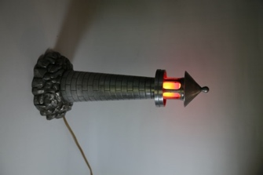
Ans: A distant relative of the Walsh's (see elsewhere) was Tom Ohara. Both families hailed from near Scranton, PA after they immigrated from Ireland. Tom was a metal worker and involved in the early use of aluminum at a time (in the early 20th century) when it's properties and abilities were not well known. He made several castings of aluminum structures of artistic merit, although was not considered an artist pe se. This lamp was given to Jim's grandmother (Victoria, she and Tom were Cousins through marriage) and sat in the front hallway/entrance, on top of a large iron radiator, at her house at 4404 Chestnut, in West Philadelphia. As you can see, it provided very little light, but was sufficient as a "night-light" for the tenants to find their way to the stairs.
16. A French Book? Oui, pourquoi?
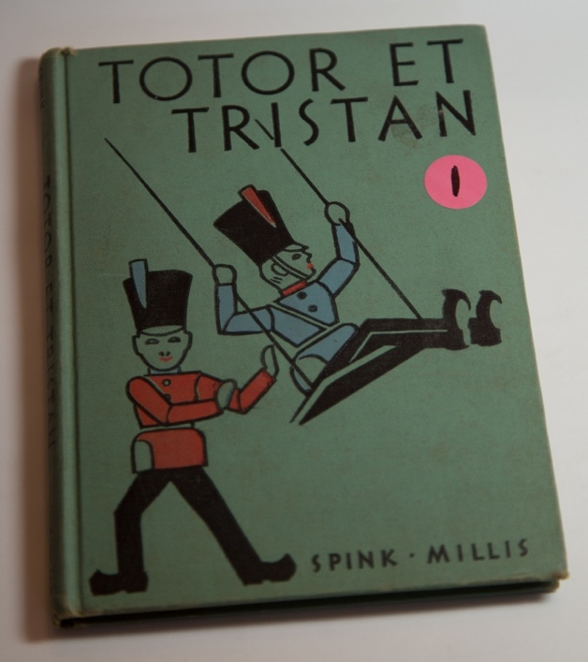
Ans: This is Jim's first grade French book. Well, not the exact one, but another copy. He did not progress very far in this book, but a number of years later, perhaps 40 or 50 years, Jim came across his original copy and said to himself, "Sacrebleu, Je n'ai jamais fini de lire ce livre." ("Oh wow, I never finished this book"). So, he proceeded to finish it and this led to his renewed interest in French and taking French lessons at the Alliance Francaise, et le reste est l'histoire. 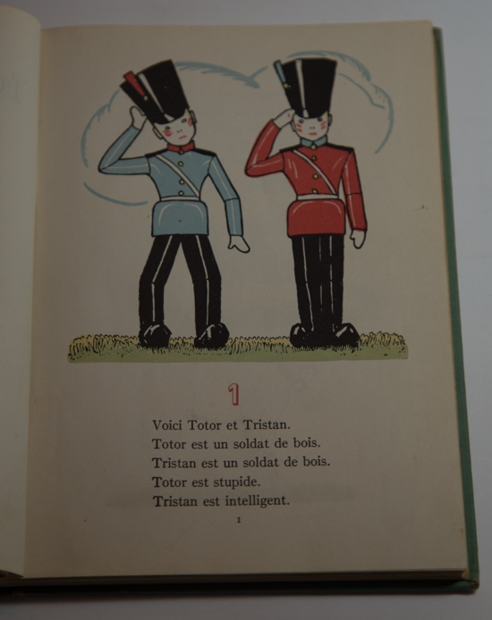

17. A name tag. What is Jim's real name and why do people call him "Lan"?
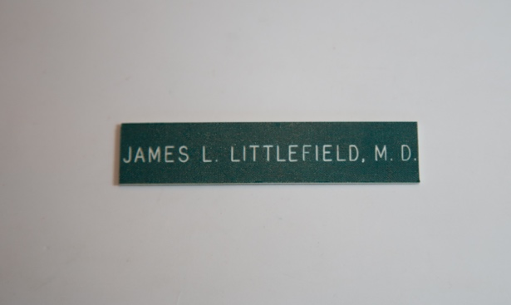
Ans: When Jim (as you may know him) was born a name was needed to fill in the birth certificate. He was going to be called by his two grandfathers, which would have been Jesse James Littlefield (Jesse M. Littlefield and James J. Walsh). Given that this might have necessarily have led to a life of robbing banks in Missouri, a change was felt appropriate. SO, substituted for the Jesse was Landreth, the familial/surname/maiden name of Jim's father's mother, Ada Landreth. Since the name Landreth was about to vanish due to a lack of male heirs, he was christened James Landreth Littlefield. However, there were so many James in the family, he was called by his middle name, but this being somewhat cumbersome, it was shortened to "Lan" and "Lan" was later changed to the familiar/diminutive form, "Lannie". As to why it appears as the feminine from "-ie", rather than "Lanny" is not known. Hence, if you hear someone call him "Lannie" you know this is likely a very old friend (before 1958) or a family member. Otherwise, you will hear "Jim".

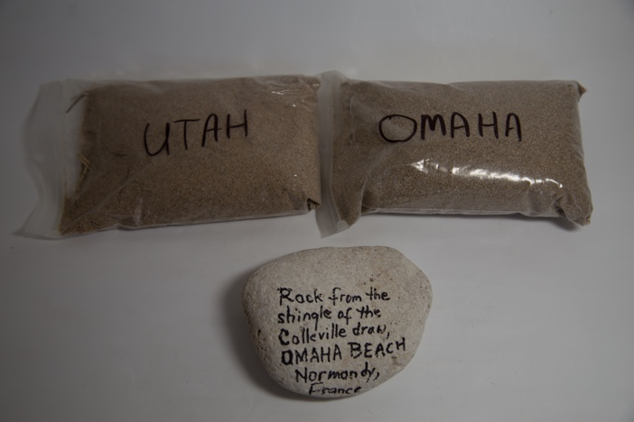
18. Sand bags labeled "Omaha" and "Utah". What gives?
Ans: No, not dirt from the Indian Reservations*. These are samples of sand from Omaha and Utah beaches in Normandy, France. Given Jim's interest in World War II, when he visited these landing sites on a tour in 2006 for the 60th Anniversary Commemoration of D-Day, he picked up these samples from the respective beaches. Omaha beach sand is said to be slightly more ferromagnetic because of the microscopic shards of iron and steal that exist there in.
*Note: it is not well known that Jim's dad, in the dark days of the depression, worked for the WPA and was involved in installing electric lights in the outhouses of Indian reservations in Southern California, among other jobs, before he joined the navy in 1942. Hence, he is know as (are you ready for this??) "the first man to wire a head for the reservation."

19. An airplane model. Can you identify it and how does it relate to Jim's family history.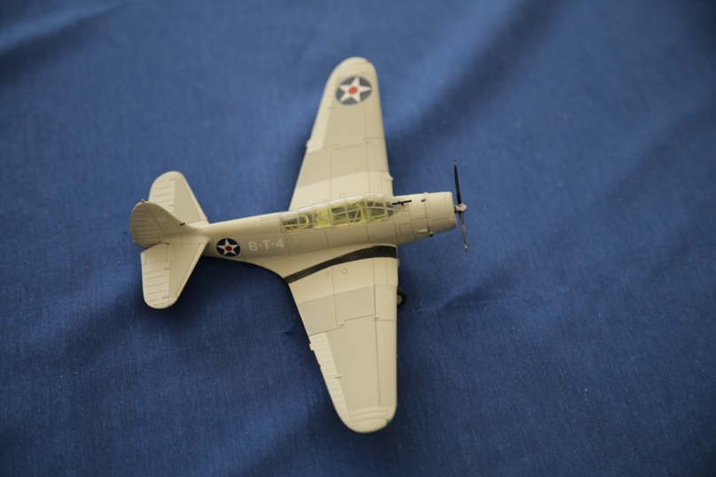
Ans: This is a TBD Devastator, torpedo bomber. There is no direct or known geneologic connection*, but this plane (or one very, very close to this model) was flown at the Battle of Midway on June 6th, 1942. In fact, it was flow from the USS Enterprise (CV-6) as part of Torpedo Squadron 6. (Many are familiar with the story of Ensign Gay and Torpedo 8). One of the air-crew of that Division was ARM 2/c Harold Francis (nicknamed "Feets"). Littlefield, who was a participant and was killed at BOM. He was radioman-gunner on Lt.(jg) Lloyd Thomas' VT-6 in 6-T-7, part of the second division attack on IJN Kaga, I believe. Jim can fill you in on the details at great length. Nevertheless, Jim likes to claim, with some validity, this Littlefield as one who won the war in the Pacific in WWII.
*There are three primary branches of Littlefields in the United States, all of which emmigrated from England. The New England branch descended from Edmund, the Southern branch, descended from William of Maryland, and the miscellaneous branch from Francis (also of New England). The first two originated from a town in southern England called Tichfield, but at seperate years of immigration. As of this time, it has not been established a direct connection of the Edmund and William families through historical records, however, a genetic analysis has been done revealing that they had a common ancestor.
20. Who is this, and what is her story?
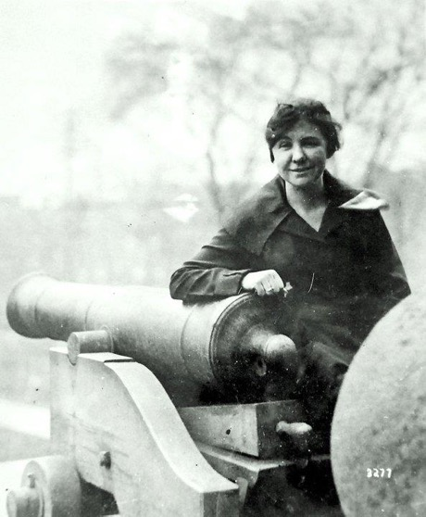
Ans: This is picture of Loretta Perfectus Walsh. She is Jim's great aunt, his mother's aunt, her father's (James J Walsh, MD) sister. She is recognized as the first enlisted woman in the Armed Services, other than as a nurse (who were generally contract nurses). From her Wikipedia entry: "Loretta Perfectus Walsh (April 22, 1896 – August 6, 1925) became the first American active-duty Navy woman, and the first woman allowed to serve as a woman, in any of the United States armed forces, as anything other than as a nurse, when she enlisted in the U.S. Naval Reserve on March 17, 1917. Walsh subsequently became the first woman U.S. Navy petty officer when she was sworn in as Chief Yeoman on March 21, 1917. Again, if you have the time, Jim can fill you in at great length on Loretta's story.

