Banana Bread (Bananakaka)
Aleda Littlefield

This recipe came from my great-aunt, Ella Swanson Sundberg, who was married to my great-uncle Axel. Axel was the brother of my grandmother, Ida Amalia Sundberg. Ella and Axel lived in Omaha for a time and before that in Chicago. In 1933, Ella gave my mother, Alice Åstrom, a recipe for banana bread. Below is my mother’s handwritten copy, recorded later in her life. Ella and Axel had no children but my mother maintained a correspondence with Ella until Ella’s passing.
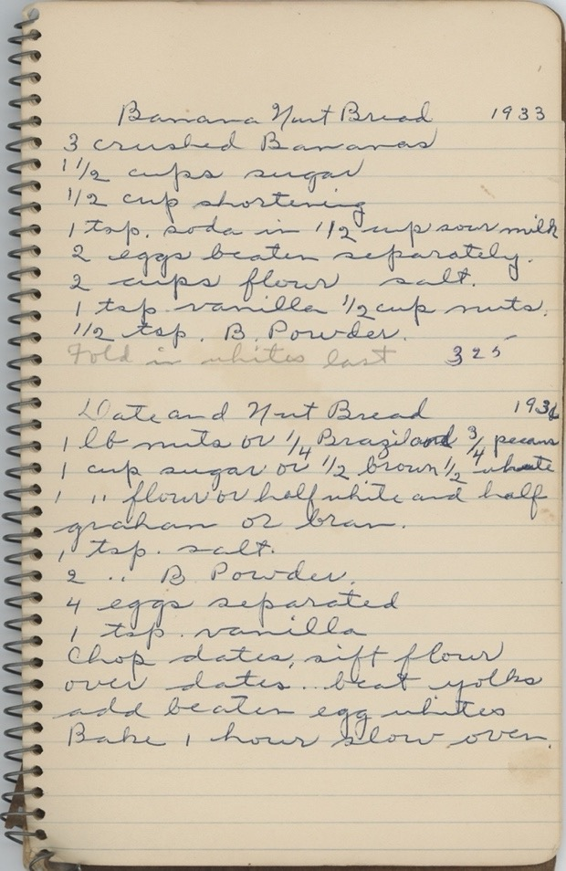
Aleda’s Banana Bread – (Alice’s Recipe)
(Note: I usually double the ingredients to make 2 loaves and give 1 away.)

1/2 cup shortening
1 cup sugar
2 cups flour
2 eggs, beaten
1/4 tsp salt
3 crushed bananas (1 cup)
½ tsp baking soda in ½ cup buttermilk or sour milk
1/4 tsp vanilla
½ tsp. baking powder
Butter for pan. Grease loaf pan with butter 9 x 5 x 3 in. Cream the shortening, egg and sugar together thoroughly. Stir in milk and bananas and vanilla. Blend dry ingredients. Mix thoroughly. Pour into pan/dish.
Bake in 350° F oven for 60 to 70 minutes or until a toothpick comes out clean from the center. A crack in the top is characteristic.

Note: this is a good way to use up over-ripe bananas.

Swedish-style banana bread isn’t as standardized as American banana bread. In Sweden, banana baking falls under the broader tradition of kaka (cakes) or quick breads, often shaped by the cozy coffee culture known as fika. The result is typically lighter, less sweet, and more subtly spiced than its U.S. counterpart.
Key traits: less sugar — often noticeably less sweet than American recipes, moist but light crumb — closer to a cake than a dense loaf, mild spices — cardamom is common, a hallmark of Scandinavian baking, neutral oils or butter — sometimes a mix, but not overly rich, yogurt or filmjölk — adds tang and tenderness; filmjölk is a cultured dairy product popular in Sweden.

Bananas first appeared in Sweden in small quantities in the late 19th century, imported through European trade networks. At that time, they were expensive, exotic, and mostly available in major cities like Stockholm and Gothenburg. The real turning point came in the early 20th century with the development of refrigerated cargo ships (“reefer ships”), which allowed bananas from Central and South America to be transported without spoiling. A key player in Scandinavia was the Swedish company Banan-Kompaniet, founded in 1909. It organized large-scale imports and helped standardize ripening and distribution, making bananas more widely available across Sweden. By the 1920s and 1930s, bananas became increasingly affordable. Advertising campaigns taught Swedes how to eat and cook with them, helping shift bananas from an “exotic curiosity” to a common fruit. After World War II, imports expanded further, and bananas became a staple in Swedish households.

